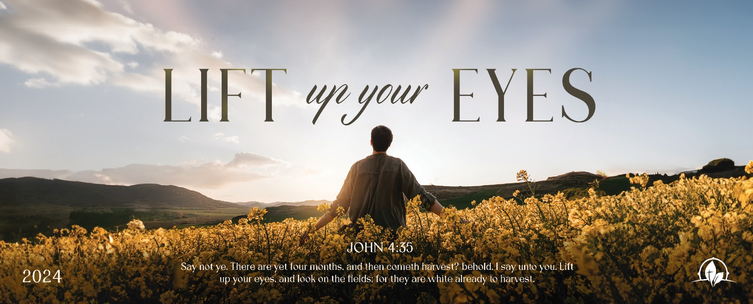

Ye Shall Know
1 Kings 20:22-34

Sunday Night, January 21, 2024
Cornerstone Baptist Church
315 Shoup Ave. West
Twin Falls Id 83301
208-733-5312 cbctwinfalls.com

Ye Shall Know
1 Kings 20:22-34
Introduction:

1Ki 20:28

- God _______________ to Show His ________________.
  - Before the ungodly. Ezek. 39:7
  - For His name. Ezek. 36:22
  - Before his people. Ex. 6:7
  - In his servants. 1 Cor. 1:27-31
- The _____________ is the ____________________.
  - Against the enemies of God. 1 Sam. 17:47; Eph. 6:12; James. 4:1-2
  - Against temptation. 1 John 2:15-17
- _____________ is Nothing Before God’s ________. Rom. 12:1-2
  - The devil has power. Rev. 20:10
  - The world has power.
  - Governments have power.
- ______________ are Learned in ___________ and in _____________. Rom. 8:28; 2 Cor. 4:15-18
  - Trials teach us.
  - Rebuke teaches us.
  - Reproof teaches us.
  - Chastisement teaches us.

Conclusion:

Ye Shall Know
1 Kings 20:22-34

Sunday Night, January 21, 2024
Cornerstone Baptist Church
315 Shoup Ave. West
Twin Falls Id 83301
208-733-5312 cbctwinfalls.com

Ye Shall Know
1 Kings 20:22-34
Introduction:

1Ki 20:28

- God _______________ to Show His ________________.
  - Before the ungodly. Ezek. 39:7
  - For His name. Ezek. 36:22
  - Before his people. Ex. 6:7
  - In his servants. 1 Cor. 1:27-31
- The _____________ is the ____________________.
  - Against the enemies of God. 1 Sam. 17:47; Eph. 6:12; James. 4:1-2
  - Against temptation. 1 John 2:15-17
- _____________ is Nothing Before God’s ________. Rom. 12:1-2
  - The devil has power. Rev. 20:10
  - The world has power.
  - Governments have power.
- ______________ are Learned in ___________ and in _____________. Rom. 8:28; 2 Cor. 4:15-18
  - Trials teach us.
  - Rebuke teaches us.
  - Reproof teaches us.
  - Chastisement teaches us.

Conclusion:

