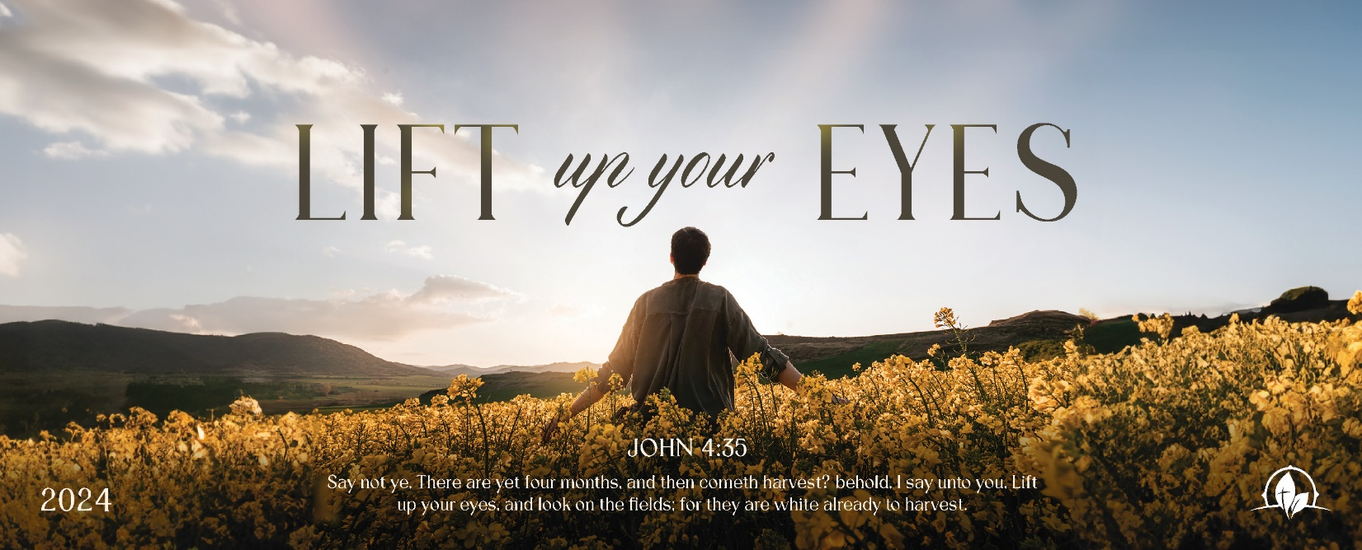

The Siege of the Enemy
1 Kings 20:1-21

Sunday Night, December 10, 2023
Cornerstone Baptist Church
315 Shoup Ave. West
Twin Falls Id 83301
208-733-5312 cbctwinfalls.com

The Siege of the Enemy
1 Kings 20:1-21
Introduction:

- The ________________________ Factor. (2-6)
1Pe 5:8-9
  - An impossibility.
  - An effort to influence.
- The ________________________ Factor. (7-8)
Pro 1:25; Pro 11:14; Pro 12:15; Pro 15:22
  - The counsel of God.
  - The counsel of the godly.
  - The clarity of counsel.
- The _______________________ Factor. (8-12)
  - A stand on the Bible.
  - A stand of the strength of the Holy Spirit.
  - A stand on God’s power.
- The _______________________ Factor. (13-14)
Psa 83:17-18
  - God encourages his saints.
  - God knows what we need.
  - God gives, we must choose to receive.
- The ________________________ Factor. (15-21)
Heb 5:9; Gal. 5:6-7
  - Ahab obeyed.
  - Ahab trusted.
  - Ahab had all other options removed.

Conclusion:

The Siege of the Enemy
1 Kings 20:1-21

Sunday Night, December 10, 2023
Cornerstone Baptist Church
315 Shoup Ave. West
Twin Falls Id 83301
208-733-5312 cbctwinfalls.com

The Siege of the Enemy
1 Kings 20:1-21
Introduction:

- The ________________________ Factor. (2-6)
1Pe 5:8-9
  - An impossibility.
  - An effort to influence.
- The ________________________ Factor. (7-8)
Pro 1:25; Pro 11:14; Pro 12:15; Pro 15:22
  - The counsel of God.
  - The counsel of the godly.
  - The clarity of counsel.
- The _______________________ Factor. (8-12)
  - A stand on the Bible.
  - A stand of the strength of the Holy Spirit.
  - A stand on God’s power.
- The _______________________ Factor. (13-14)
Psa 83:17-18
  - God encourages his saints.
  - God knows what we need.
  - God gives, we must choose to receive.
- The ________________________ Factor. (15-21)
Heb 5:9; Gal. 5:6-7
  - Ahab obeyed.
  - Ahab trusted.
  - Ahab had all other options removed.

Conclusion:

