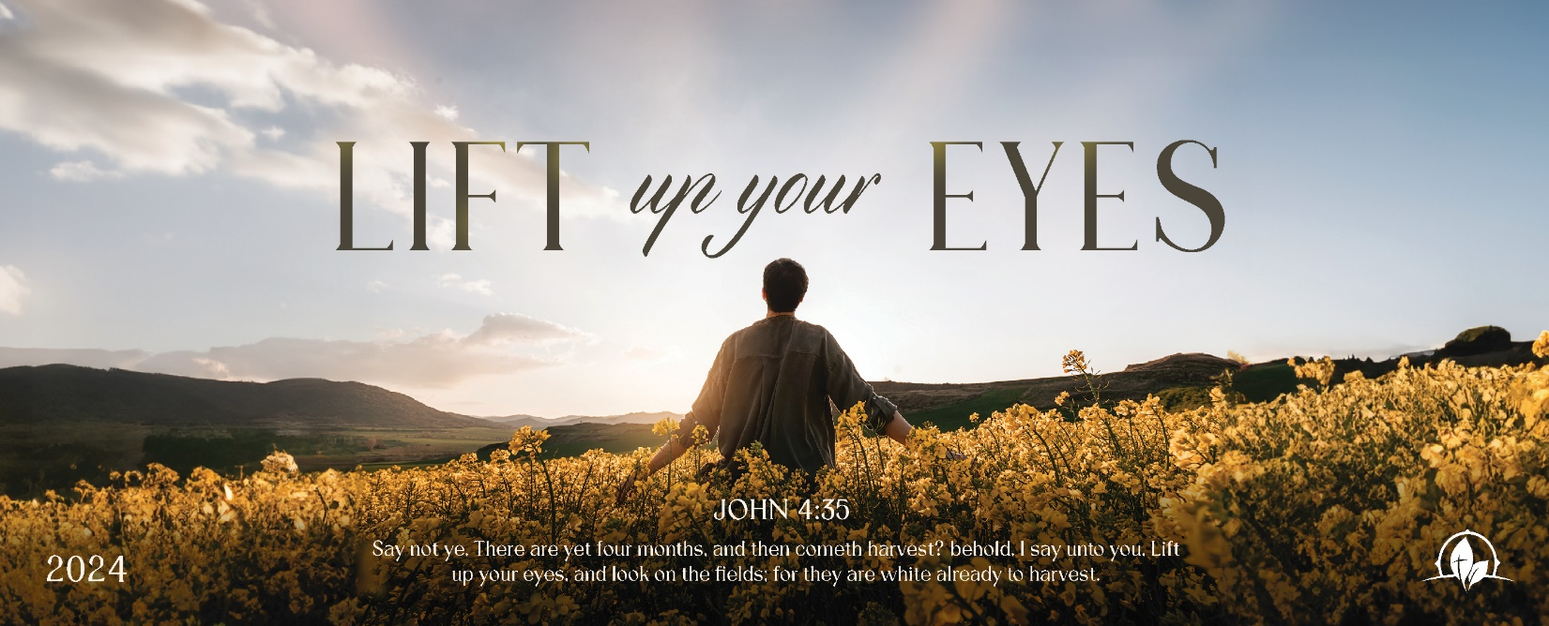

A Faithful Completion
1 Kings 19:7-18

Sunday Night, December 10, 2023
Cornerstone Baptist Church
315 Shoup Ave. West
Twin Falls Id 83301
208-733-5312 cbctwinfalls.com

A Faithful Completion
1 Kings 19:15-21
Introduction:
Heb 12:1-2; Joh 4:35
- Lift Our Eyes Back to God.
  - God’s majesty.
  - God’s personality.
- Lift Our Eyes Back to God’s Plan. Psa 138:8
  - A personal plan.
  - A personal perspective.
- Lift Our Eyes to What is Before Us.
Act 9:15-16; 2Co 12:4-5; 1Co 2:9
  - The hope ahead of us.
  - The usefulness ahead of us.
Heb 13:20-21
- Lift Our Eyes to the Opportunity.
Joh 4:35
  - A lost world.
  - A gospel impacted world.
  - A world in need of Jesus.

Conclusion:

___________________ do not diminish _________________.

God’s _________________ gives godly __________________.

________________ transfers to _______________________.

A Faithful Completion
1 Kings 19:7-18

Sunday Night, December 10, 2023
Cornerstone Baptist Church
315 Shoup Ave. West
Twin Falls Id 83301
208-733-5312 cbctwinfalls.com

A Faithful Completion
1 Kings 19:15-21
Introduction:
Heb 12:1-2; Joh 4:35
- Lift Our Eyes Back to God.
  - God’s majesty.
  - God’s personality.
- Lift Our Eyes Back to God’s Plan. Psa 138:8
  - A personal plan.
  - A personal perspective.
- Lift Our Eyes to What is Before Us.
Act 9:15-16; 2Co 12:4-5; 1Co 2:9
  - The hope ahead of us.
  - The usefulness ahead of us.
Heb 13:20-21
- Lift Our Eyes to the Opportunity.
Joh 4:35
  - A lost world.
  - A gospel impacted world.
  - A world in need of Jesus.

Conclusion:

___________________ do not diminish _________________.

God’s _________________ gives godly __________________.

________________ transfers to _______________________.

