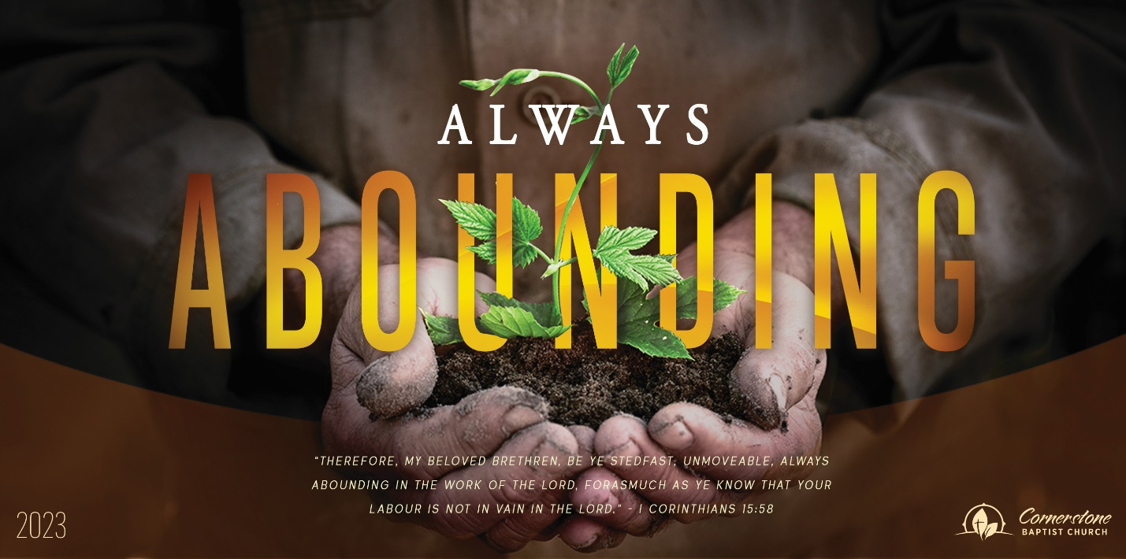
Sunday Dec. 10, 2023

The Word was God

Cornerstone Baptist Church
315 Shoup Ave. West
Twin Falls Id 83301
208-733-5312 cbctwinfalls.com

The Word was God
John 1:1-14
Introduction:
- Jesus is ___________________________. (1) Col 1:17; Joh 17:5
- Jesus is __________________________. (1) Deu 6:4
  - The person of Jesus is God.
  - The personality of Jesus is God.
  - The nature of Jesus is God.
- Jesus is the ___________________________. (3) Col 1:16; Jer 51:15; Exo 8:19
  - The immensity of the universe.
  - The precision of the universe.
  - The minuteness of the universe.
- Jesus is the Life. (4) Col 1:15; Joh 14:9
  - Giver of physical life. Gen 1:27; Ecc 7:29
  - Giver of spiritual life. 1Jn 5:1; Joh 3:36
- Jesus is the __________________________. (5) Joh 8:12; Joh 9:5; Rev 21:23
  - Light of forgiveness.
  - Light of hope.
  - Light of freedom.
  - Light of love.
  - Light of mercy.
  - Light of grace.
  - Light of kindness.
- Jesus is the ______________________________. (12-13)
  - Who Jesus is makes him able to save from sin.
  - Who Jesus is makes him the only Savior.
  - Who Jesus is makes him worthy of giving our lives in service, sacrifice, and faithfulness.

Conclusion:

Sunday Dec. 10, 2023

The Word was God

Cornerstone Baptist Church
315 Shoup Ave. West
Twin Falls Id 83301
208-733-5312 cbctwinfalls.com

The Word was God
John 1:1-14
Introduction:
- Jesus is ___________________________. (1) Col 1:17; Joh 17:5
- Jesus is __________________________. (1) Deu 6:4
  - The person of Jesus is God.
  - The personality of Jesus is God.
  - The nature of Jesus is God.
- Jesus is the ___________________________. (3) Col 1:16; Jer 51:15; Exo 8:19
  - The immensity of the universe.
  - The precision of the universe.
  - The minuteness of the universe.
- Jesus is the Life. (4) Col 1:15; Joh 14:9
  - Giver of physical life. Gen 1:27; Ecc 7:29
  - Giver of spiritual life. 1Jn 5:1; Joh 3:36
- Jesus is the __________________________. (5) Joh 8:12; Joh 9:5; Rev 21:23
  - Light of forgiveness.
  - Light of hope.
  - Light of freedom.
  - Light of love.
  - Light of mercy.
  - Light of grace.
  - Light of kindness.
- Jesus is the ______________________________. (12-13)
  - Who Jesus is makes him able to save from sin.
  - Who Jesus is makes him the only Savior.
  - Who Jesus is makes him worthy of giving our lives in service, sacrifice, and faithfulness.

Conclusion:

