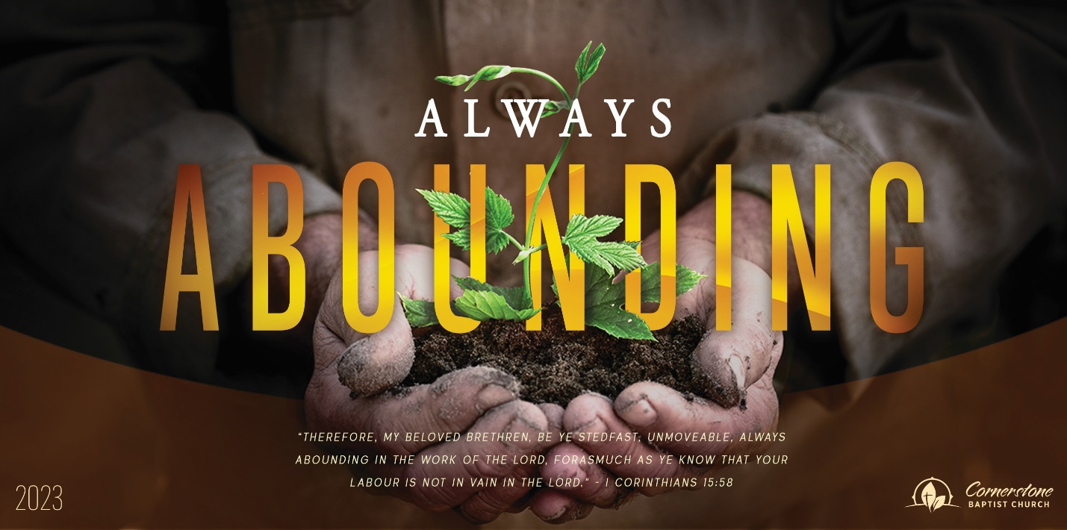
Sunday Dec. 24, 2023

An Eye Opener

Cornerstone Baptist Church
315 Shoup Ave. West
Twin Falls Id 83301
208-733-5312 cbctwinfalls.com

An Eye Opener
John 3:17

Introduction:

- The Person _____________ ______________________.
  - God’s love.
    - Rom 5:6-8
  - God’s character.
- The Person _____________________.
  - Specific mission. 2 Cor. 5:21; 1 Tim. 2:5-6; Matt. 20:28
  - Specific representation. 1 John 4:9-10
- The Person _____________ _________________.
  - Sent to the hurting.
    - Man of the Gadarenes. Mark 5
    - Woman at the well. John 4
  - Sent to the religious. John 7:32-36
  - Sent to the doubting. John 20:24-28
- The Person’s ______________________. John 1:14, 18
  - Grace.
  - Truth.

Conclusion:

Joh 3:18-21

Sunday Dec. 24, 2023

An Eye Opener

Cornerstone Baptist Church
315 Shoup Ave. West
Twin Falls Id 83301
208-733-5312 cbctwinfalls.com

An Eye Opener
John 3:17

Introduction:

- The Person _____________ ______________________.
  - God’s love.
    - Rom 5:6-8
  - God’s character.
- The Person _____________________.
  - Specific mission. 2 Cor. 5:21; 1 Tim. 2:5-6; Matt. 20:28
  - Specific representation. 1 John 4:9-10
- The Person _____________ _________________.
  - Sent to the hurting.
    - Man of the Gadarenes. Mark 5
    - Woman at the well. John 4
  - Sent to the religious. John 7:32-36
  - Sent to the doubting. John 20:24-28
- The Person’s ______________________. John 1:14, 18
  - Grace.
  - Truth.

Conclusion:

Joh 3:18-21

