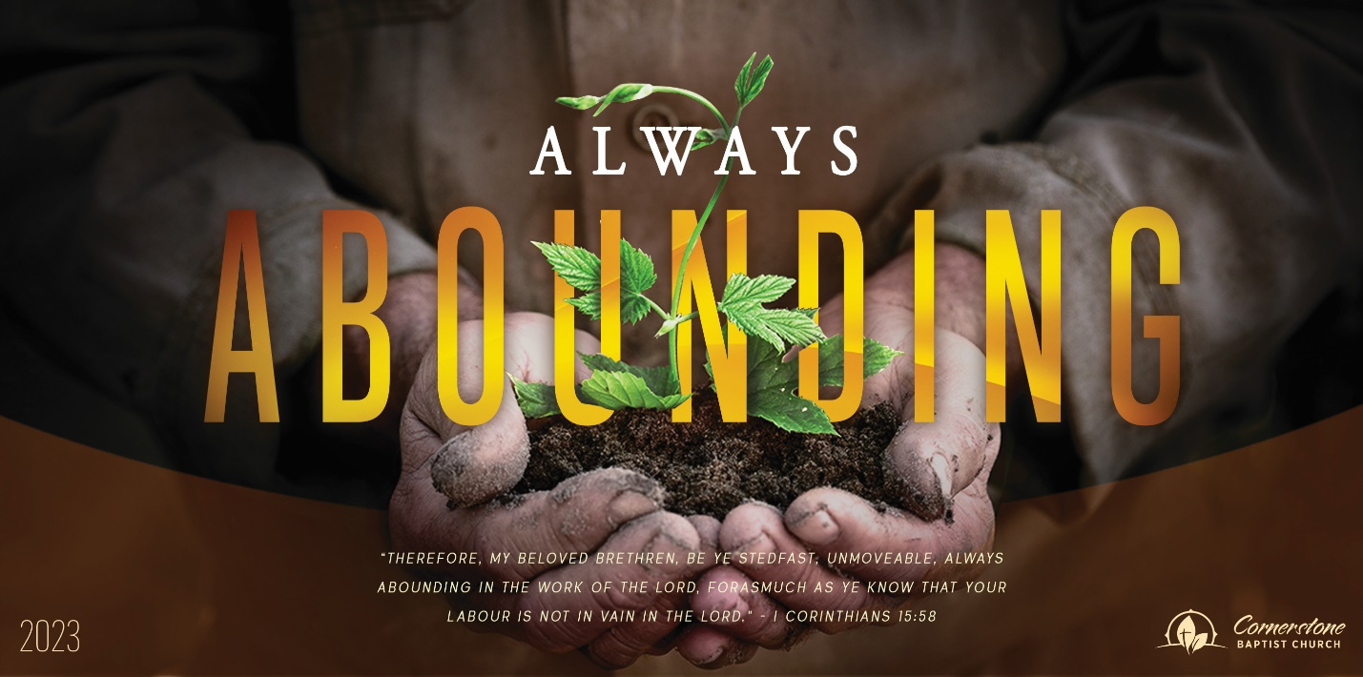
Sunday Nov. 19, 2023

Overcome with Good

Cornerstone Baptist Church
315 Shoup Ave. West
Twin Falls Id 83301
208-733-5312 cbctwinfalls.com

Overcome with Good
Romans 12:14-21

Introduction:

- A Choice to _________________________.
- Pro 24:17-18
- A Choice to _________________________.
- Lepers outside Jerusalem. 2Ki 7:9
- A Choice to Be ______________________.
- 1Pe 3:8-10; Php 1:27; 2Co 13:11
- A Choice to _________________________.
- Pro 20:22; 1Th 5:15
- A Choice to Be _______________________.
  - Heb 13:18
- A Choice of __________________________.
  - Heb 12:14
  - Mat 5:39
- A Choice to _________________________.
  - Pro 25:21; Son 8:6-7

Conclusion:
1Pe 2:21-25; Gal 5:22-25

Sunday Nov. 19, 2023

Overcome with Good

Cornerstone Baptist Church
315 Shoup Ave. West
Twin Falls Id 83301
208-733-5312 cbctwinfalls.com

Overcome with Good
Romans 12:14-21

Introduction:

- A Choice to _________________________.
- Pro 24:17-18
- A Choice to _________________________.
- Lepers outside Jerusalem. 2Ki 7:9
- A Choice to Be ______________________.
- 1Pe 3:8-10; Php 1:27; 2Co 13:11
- A Choice to _________________________.
- Pro 20:22; 1Th 5:15
- A Choice to Be _______________________.
  - Heb 13:18
- A Choice of __________________________.
  - Heb 12:14
  - Mat 5:39
- A Choice to _________________________.
  - Pro 25:21; Son 8:6-7

Conclusion:
1Pe 2:21-25; Gal 5:22-25

