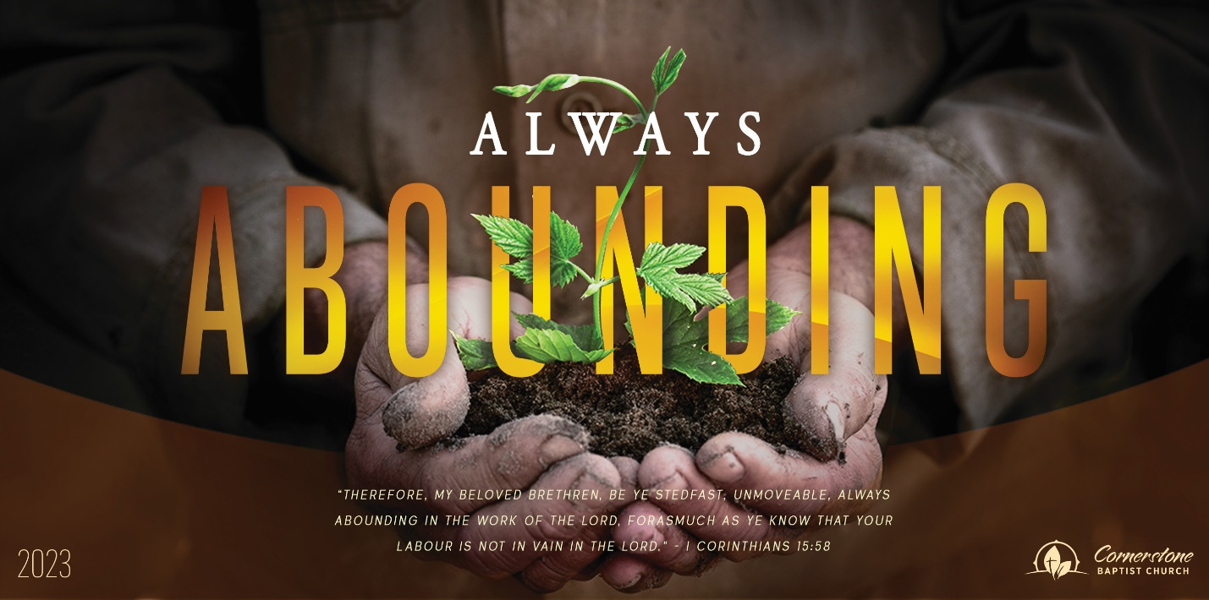
Go Again
1 Kings 18:41-46

Sunday Night, October 29, 2023
Cornerstone Baptist Church
315 Shoup Ave. West
Twin Falls Id 83301
208-733-5312 cbctwinfalls.com

Go Again
1 Kings 18:41-46
Introduction:

- The Faith of Elijah.
Faith develops in our lives.
Rom 10:17; Isa 55:9-12; Jas 1:21-22; 1Th 2:13
  - Through knowing and studying the Word of God.
  - Through the favor of God.
  - Through experience of God’s faithfulness.

- The _______________________ Prayer. Matt. 6:1-18
Rejecting of pride to break through in prayer.
  - Revealed in how we talk about ourselves.
  - Revealed in how we talk about others.

- The _______________________ of Prayer. James 1:1-4
  - Comes through persistence.
  - Comes through humility.
  - Comes through intention.

Conclusion:
Develops a strong _____________________.

We need a regular ____________________.
We need a regular ____________________.
We need a regular ____________ and _____________ to God’s Word.

Go Again
1 Kings 18:41-46

Sunday Night, October 29, 2023
Cornerstone Baptist Church
315 Shoup Ave. West
Twin Falls Id 83301
208-733-5312 cbctwinfalls.com

Go Again
1 Kings 18:41-46
Introduction:

- The Faith of Elijah.
Faith develops in our lives.
Rom 10:17; Isa 55:9-12; Jas 1:21-22; 1Th 2:13
  - Through knowing and studying the Word of God.
  - Through the favor of God.
  - Through experience of God’s faithfulness.

- The _______________________ Prayer. Matt. 6:1-18
Rejecting of pride to break through in prayer.
  - Revealed in how we talk about ourselves.
  - Revealed in how we talk about others.

- The _______________________ of Prayer. James 1:1-4
  - Comes through persistence.
  - Comes through humility.
  - Comes through intention.

Conclusion:
Develops a strong _____________________.

We need a regular ____________________.
We need a regular ____________________.
We need a regular ____________ and _____________ to God’s Word.

