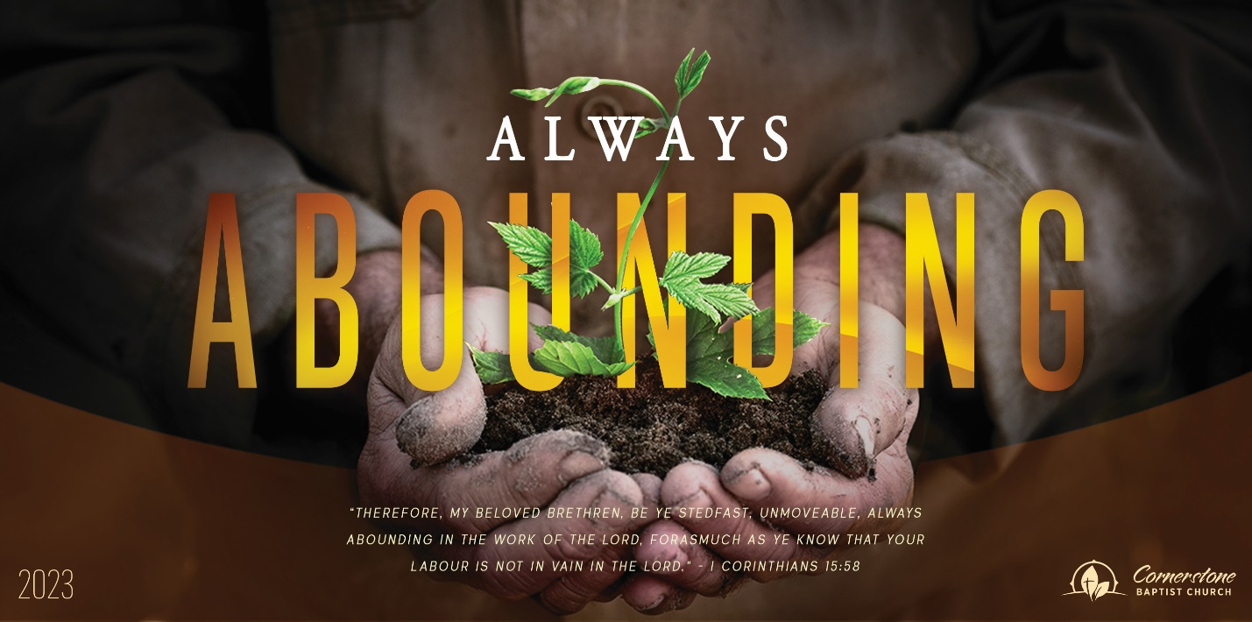
Stuck in a Rut
1 Kings 18:21

Sunday Night, October 1, 2023
Cornerstone Baptist Church
315 Shoup Ave. West
Twin Falls Id 83301
208-733-5312 cbctwinfalls.com

Stuck in a Rut
1 Kings 18:21
Introduction:
Pro 28:4; Luk 16:13
A _________________ problem.
An _________________ problem.
A __________________ problem.
A __________________ problem.

- A Personal _______________________.
1Co 10:21-22
- A Personal _______________________.
  - Am I committed to pursuing God?
  - Am I committed to the church of God?
  - Am I willfully continuing in disobedience?
  - Am I easily impatient?
  - Am I actively serving others?
  - Am I listening to the Spirit?
- A Personal ________________________.
  - Make a choice.
  - Make a commitment.
  - Make a difference.

Conclusion:
They answered not a word.

Stuck in a Rut
1 Kings 18:21

Sunday Night, October 1, 2023
Cornerstone Baptist Church
315 Shoup Ave. West
Twin Falls Id 83301
208-733-5312 cbctwinfalls.com

Stuck in a Rut
1 Kings 18:21
Introduction:
Pro 28:4; Luk 16:13
A _________________ problem.
An _________________ problem.
A __________________ problem.
A __________________ problem.

- A Personal _______________________.
1Co 10:21-22
- A Personal _______________________.
  - Am I committed to pursuing God?
  - Am I committed to the church of God?
  - Am I willfully continuing in disobedience?
  - Am I easily impatient?
  - Am I actively serving others?
  - Am I listening to the Spirit?
- A Personal ________________________.
  - Make a choice.
  - Make a commitment.
  - Make a difference.

Conclusion:
They answered not a word.

