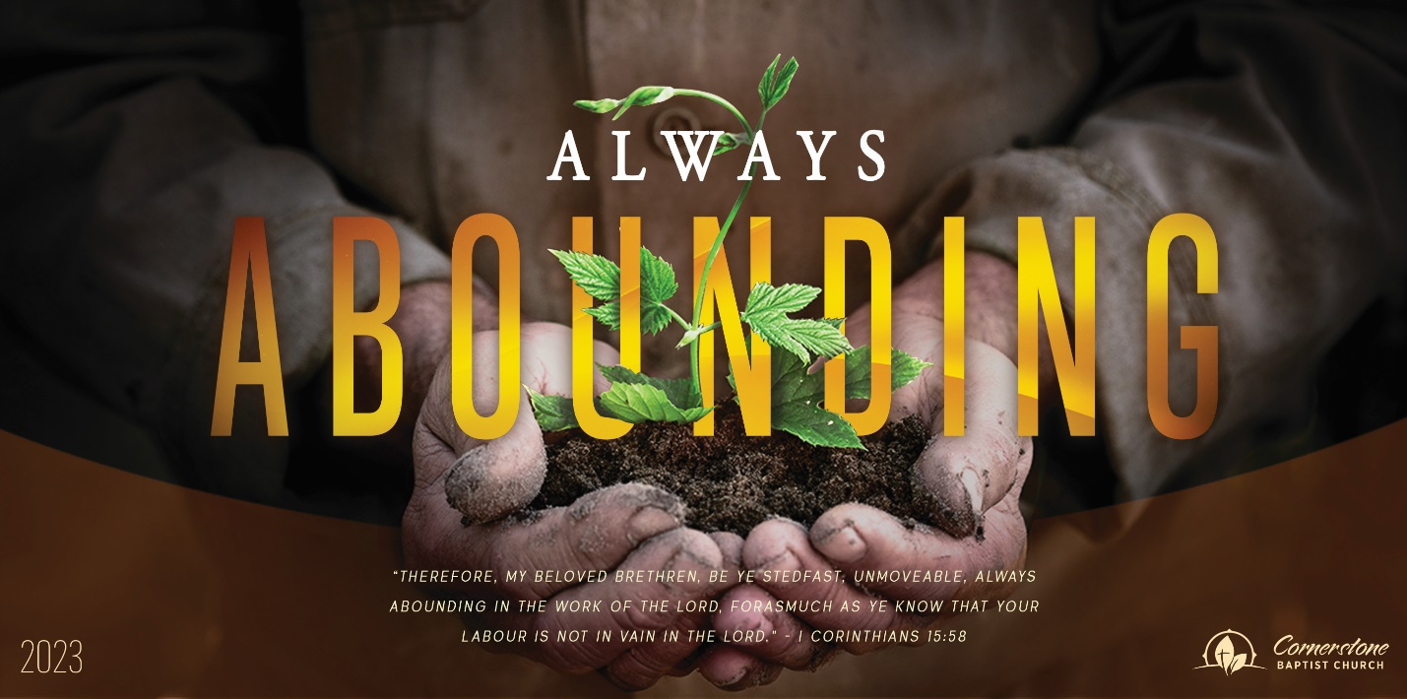
Let the Fire Fall
1 Kings 18:23-40

Sunday Night, October 29, 2023
Cornerstone Baptist Church
315 Shoup Ave. West
Twin Falls Id 83301
208-733-5312 cbctwinfalls.com

Let the Fire Fall
1 Kings 18:23-40
Introduction:
What does it mean to say, “Let the fire fall” in my life today?

Heb 11:1-2; Heb 11:32; Heb 11:6

- Standing Strong for _________________________.
  - The weight of digression.
  - The weight of depression.
  - The weight of desperation.
- Staring Straight at the ________________________.
  - The intensity of sin.
  - The intensity of false worship.
  - The intensity of pain.
- Starting Spotless for _________________________.
Psa 15:1-2
  - The choice of renewal.
  - The consciousness of renewal.
  - The capability of renewal.
- Selecting Submission in _____________________.
Psa 139:23-24; Psa 19:12-13
  - Pray in combat.
  - Pray in the calmness.
  - Pray in connection.

Conclusion:

Let the Fire Fall
1 Kings 18:23-40

Sunday Night, October 29, 2023
Cornerstone Baptist Church
315 Shoup Ave. West
Twin Falls Id 83301
208-733-5312 cbctwinfalls.com

Let the Fire Fall
1 Kings 18:23-40
Introduction:
What does it mean to say, “Let the fire fall” in my life today?

Heb 11:1-2; Heb 11:32; Heb 11:6

- Standing Strong for _________________________.
  - The weight of digression.
  - The weight of depression.
  - The weight of desperation.
- Staring Straight at the ________________________.
  - The intensity of sin.
  - The intensity of false worship.
  - The intensity of pain.
- Starting Spotless for _________________________.
Psa 15:1-2
  - The choice of renewal.
  - The consciousness of renewal.
  - The capability of renewal.
- Selecting Submission in _____________________.
Psa 139:23-24; Psa 19:12-13
  - Pray in combat.
  - Pray in the calmness.
  - Pray in connection.

Conclusion:

