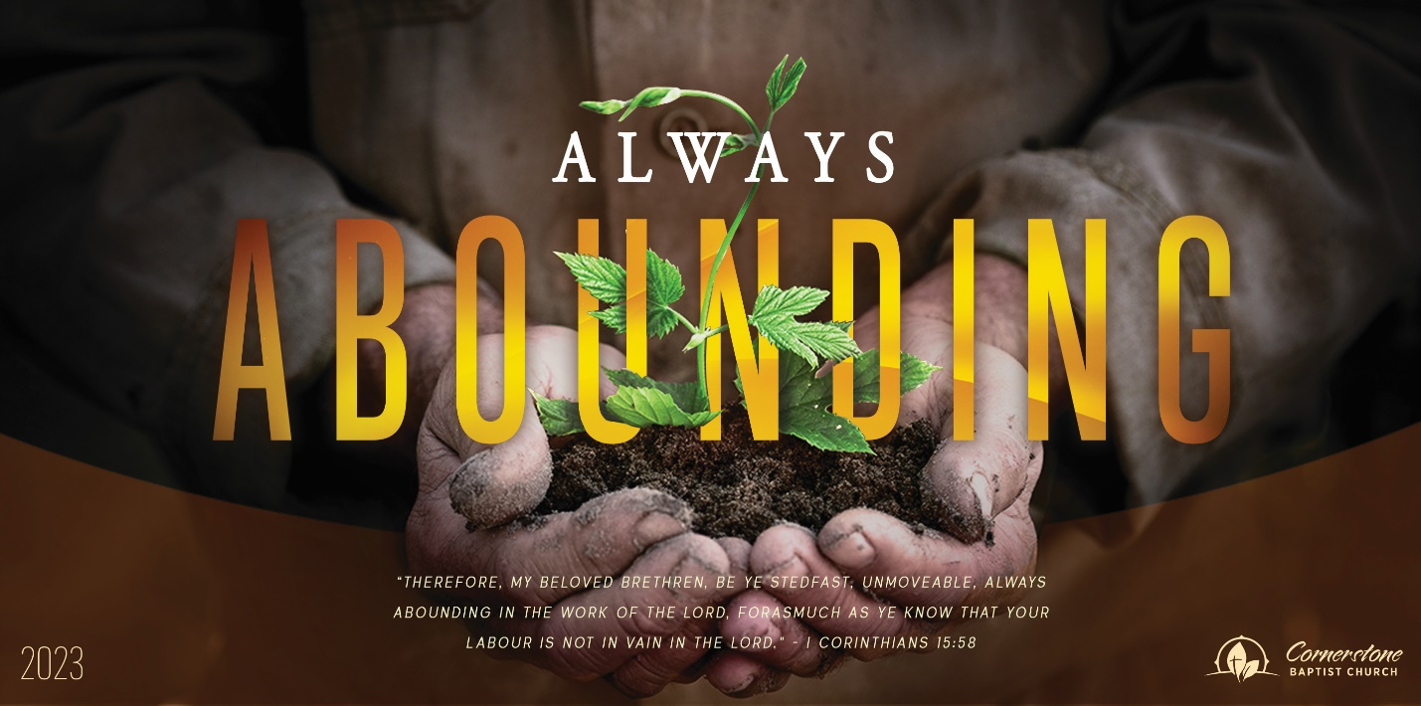
Sunday October 29, 2023

Grace Given to Us

Cornerstone Baptist Church
315 Shoup Ave. West
Twin Falls Id 83301
208-733-5312 cbctwinfalls.com

Grace Given to Us
Romans 12:5-8

Introduction:
The believer’s relationship to God is adjusted by the believer’s consecration of his own body to God.

The believer’s relationship to other believers is adjusted by the believer’s consideration for the new body.

- A ____________ Grace. (Rom 12:6 … grace that is given to us…
- A ____________ Grace. (Rom 12:6 Having then gifts differing…)
- An ___________ Grace. (Rom 12:5 So we, being many, are one body in Christ…)
- A ____________ Grace. Acts 6
- An ____________ Grace.

Conclusion:
My specific grace is it to __________________ Jesus.
My grace is not my ____________ it is the _____________ of Jesus.
My grace is not my ______________ but reveals the __________ of Jesus.

Sunday October 29, 2023

Grace Given to Us

Cornerstone Baptist Church
315 Shoup Ave. West
Twin Falls Id 83301
208-733-5312 cbctwinfalls.com

Grace Given to Us
Romans 12:5-8

Introduction:
The believer’s relationship to God is adjusted by the believer’s consecration of his own body to God.

The believer’s relationship to other believers is adjusted by the believer’s consideration for the new body.

- A ____________ Grace. (Rom 12:6 … grace that is given to us…
- A ____________ Grace. (Rom 12:6 Having then gifts differing…)
- An ___________ Grace. (Rom 12:5 So we, being many, are one body in Christ…)
- A ____________ Grace. Acts 6
- An ____________ Grace.

Conclusion:
My specific grace is it to __________________ Jesus.
My grace is not my ____________ it is the _____________ of Jesus.
My grace is not my ______________ but reveals the __________ of Jesus.

