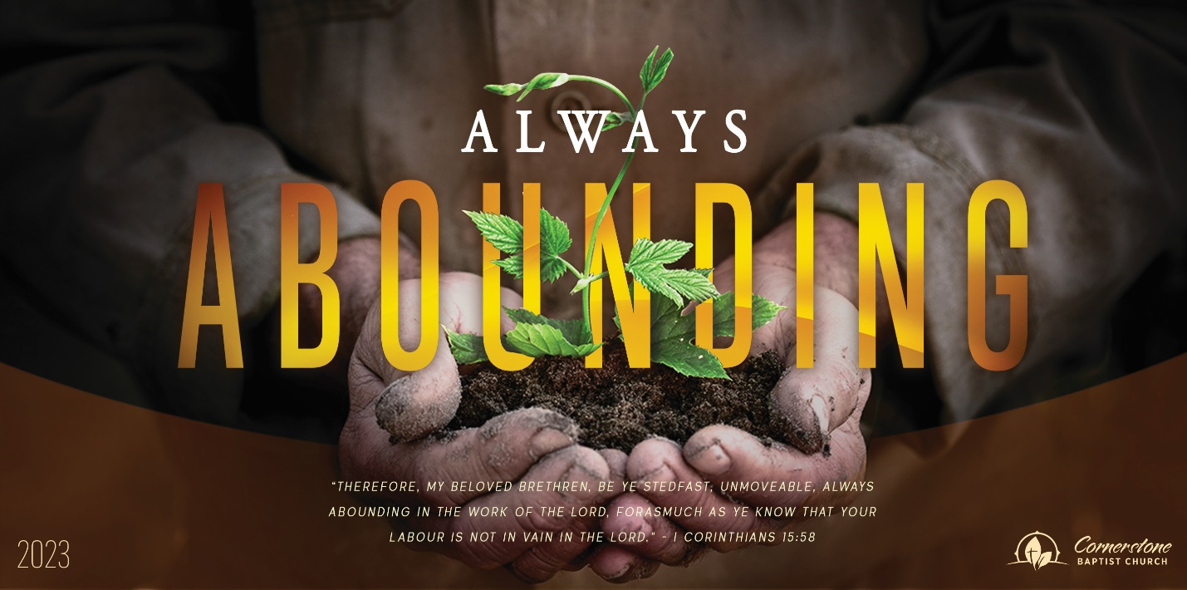
Sunday October 22, 2023

God’s Development of Our Church

Cornerstone Baptist Church
315 Shoup Ave. West
Twin Falls Id 83301
208-733-5312 cbctwinfalls.com

God’s Development of Our Church
Romans 12:3-8
Introduction:

- The Search for _______________________________.
Ecc 12:13-14; Luke 19:11-22
  - A life that counts.
  - A life lived on purpose.
  - A life that is investing in others.
  - Recognizing God’s measure of faith.

- The Solution of __________________________.
Num 12:1-2; Rev 3:17
  - This solution is for every person.
  - This solution is rooted in humility and rest in Christ.
  - This solution is rooted in confidence in Jesus Christ.
1Co 13:11-12

- The Satisfaction of ________________________.
1Co 12:14; Eph 4:25
  - A unique role. (valuable)
  - A unique entity. (body)
  - A unique connection. (affecting each other)
  - A unique command. (wait on)
  - A unique spirit. (cheerfulness)

Conclusion:
Do I use the gifts God has given me for Jesus?
Do I use the gifts God has given me with a good spirit (cheerfulness)?
Do I use the gifts God has given me with a team (body) attitude?
Do I know the measure of faith God has given unto me?
Am I content with that measure?
Am I content with the measure of faith God has given to others?
Sunday October 22, 2023

God’s Development of Our Church

Cornerstone Baptist Church
315 Shoup Ave. West
Twin Falls Id 83301
208-733-5312 cbctwinfalls.com

God’s Development of Our Church
Romans 12:3-8
Introduction:

- The Search for _______________________________.
Ecc 12:13-14; Luke 19:11-22
  - A life that counts.
  - A life lived on purpose.
  - A life that is investing in others.
  - Recognizing God’s measure of faith.

- The Solution of __________________________.
Num 12:1-2; Rev 3:17
  - This solution is for every person.
  - This solution is rooted in humility and rest in Christ.
  - This solution is rooted in confidence in Jesus Christ.
1Co 13:11-12

- The Satisfaction of ________________________.
1Co 12:14; Eph 4:25
  - A unique role. (valuable)
  - A unique entity. (body)
  - A unique connection. (affecting each other)
  - A unique command. (wait on)
  - A unique spirit. (cheerfulness)

Conclusion:
Do I use the gifts God has given me for Jesus?
Do I use the gifts God has given me with a good spirit (cheerfulness)?
Do I use the gifts God has given me with a team (body) attitude?
Do I know the measure of faith God has given unto me?
Am I content with that measure?
Am I content with the measure of faith God has given to others?

