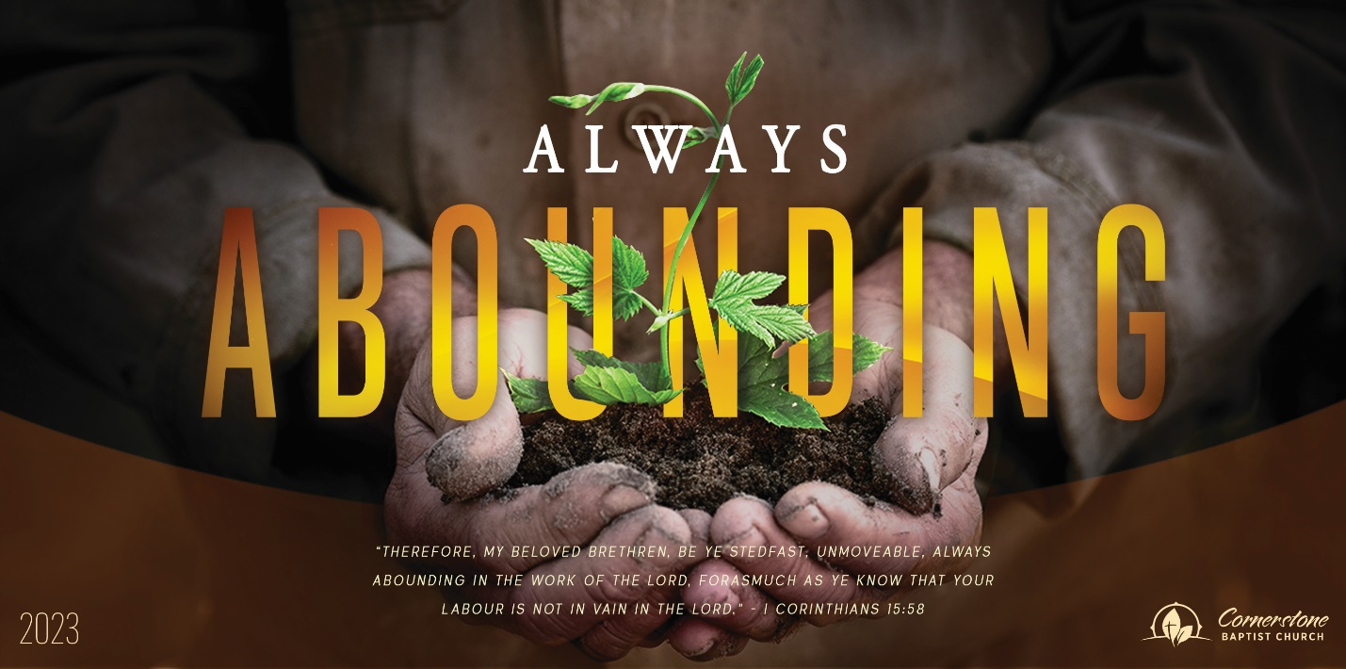
Sunday October 8, 2023

Finding Fulfillment

Cornerstone Baptist Church
315 Shoup Ave. West
Twin Falls Id 83301
208-733-5312 cbctwinfalls.com

Finding Fulfillment
Romans 12:1-2

Introduction:

- The ________________________.
Tit 3:4-8; Luke 6:36; Lam. 3:22-23; Rom. 5:6-8
  - Living sacrifice. Heb. 10:22-25
  - Holy sacrifice. Col. 3:2-6
  - Acceptable sacrifice. John 3:7

- The ___________________________. Gen. 13:10-11
  - A command.
  - A condition.
  - A consistency.

- The ____________________________.
Tit 3:5; 1 Sam. 8:19-20
  - A renewed mind. 2Cor. 4:16; Eph. 4:23-24; Php. 3:13-14; Col. 3:10
  - A regulated mission.
  - A relevant mark. 1Jn 2:17

Conclusion:

Sunday October 8, 2023

Finding Fulfillment

Cornerstone Baptist Church
315 Shoup Ave. West
Twin Falls Id 83301
208-733-5312 cbctwinfalls.com

Finding Fulfillment
Romans 12:1-2

Introduction:

- The ________________________.
Tit 3:4-8; Luke 6:36; Lam. 3:22-23; Rom. 5:6-8
  - Living sacrifice. Heb. 10:22-25
  - Holy sacrifice. Col. 3:2-6
  - Acceptable sacrifice. John 3:7

- The ___________________________. Gen. 13:10-11
  - A command.
  - A condition.
  - A consistency.

- The ____________________________.
Tit 3:5; 1 Sam. 8:19-20
  - A renewed mind. 2Cor. 4:16; Eph. 4:23-24; Php. 3:13-14; Col. 3:10
  - A regulated mission.
  - A relevant mark. 1Jn 2:17

Conclusion:

