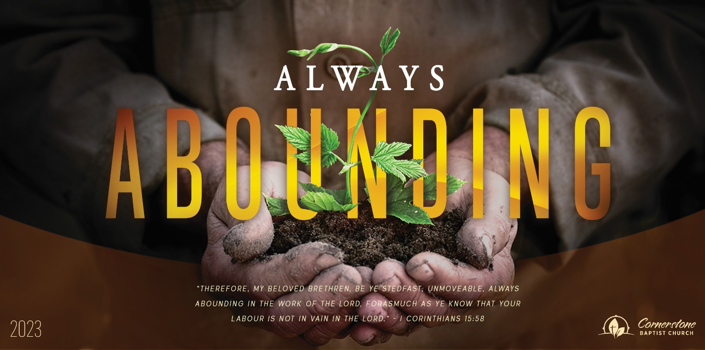
God’s Precious Saints
Psalm 116:15

Sunday Night, August 27, 2023
Cornerstone Baptist Church
315 Shoup Ave. West
Twin Falls Id 83301
208-733-5312 cbctwinfalls.com

God’s Precious Saints
Psalm 116:15
Introduction:
The Lord accounts the death of His saints of so much importance, that he will not suffer their enemies cut them off before His appointed time; all the circumstances of their death being regulated by infinite wisdom and love for their final and eternal benefit.

- A Saint is Committed to the _________________________.
- A Saint is Committed __________________.
- A Saint is Committed to ____________________.
- A Saint is Committed to ___________________.
- A Saint is Committed to _________________________.
- A Saint is Committed to ______________________.
- A Saint is Committed to ____________________________.

Conclusion:

God’s Precious Saints
Psalm 116:15

Sunday Night, August 27, 2023
Cornerstone Baptist Church
315 Shoup Ave. West
Twin Falls Id 83301
208-733-5312 cbctwinfalls.com

God’s Precious Saints
Psalm 116:15
Introduction:
The Lord accounts the death of His saints of so much importance, that he will not suffer their enemies cut them off before His appointed time; all the circumstances of their death being regulated by infinite wisdom and love for their final and eternal benefit.

- A Saint is Committed to the _________________________.
- A Saint is Committed __________________.
- A Saint is Committed to ____________________.
- A Saint is Committed to ___________________.
- A Saint is Committed to _________________________.
- A Saint is Committed to ______________________.
- A Saint is Committed to ____________________________.

Conclusion:

