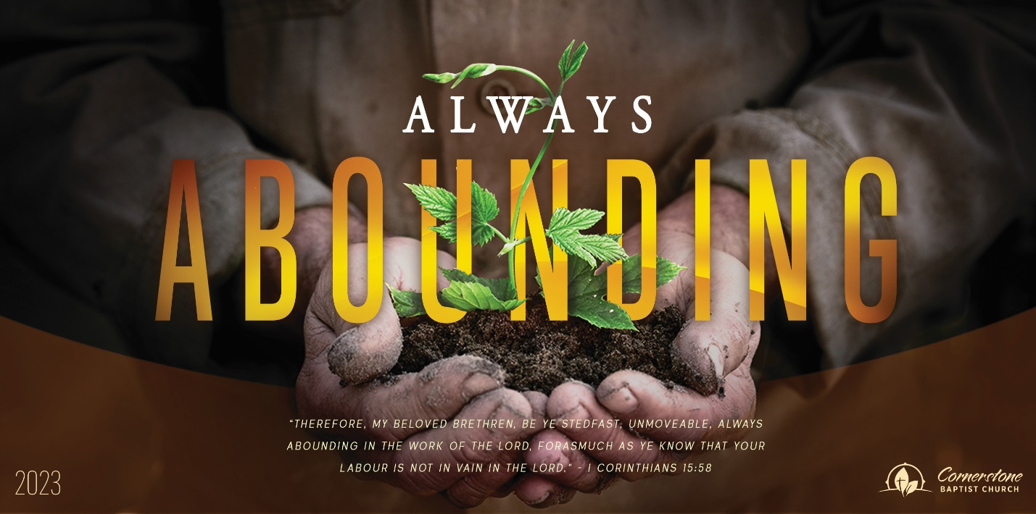
God’s Placement Plan
1 Kings 18:1-15

Sunday Night, September 3, 2023
Cornerstone Baptist Church
315 Shoup Ave. West
Twin Falls Id 83301
208-733-5312 cbctwinfalls.com

God’s Placement Plan
1 Kings 18:1-15
Introduction:

- Obadiah _____________________ the Lord. Vs.3
- Feared to action.
- Feared to sacrifice.
- Obadiah ______________________ Orders. Vs. 5-6
1Ti 6:1 Let as many servants as are under the yoke count their own masters worthy of all honour, that the name of God and his doctrine be not blasphemed.
  - A necessary search.
  - An obedient search.
- Obadiah ______________________ to have Faith. Vs. 7-13
  - A point of fear.
  - A gap of faith.
    - Psa 78:40-42; Heb. 11:6
- Obadiah’s _____________________ was Secure. Vss. 14-15
1Pe 1:5; Jud 1:24; 2Ti 1:12; Php 1:6
  - Secured by the God’s Word through the prophet.
  - We are secure by the Word of God.

Conclusion:

God’s Placement Plan
1 Kings 18:1-15

Sunday Night, September 3, 2023
Cornerstone Baptist Church
315 Shoup Ave. West
Twin Falls Id 83301
208-733-5312 cbctwinfalls.com

God’s Placement Plan
1 Kings 18:1-15
Introduction:

- Obadiah _____________________ the Lord. Vs.3
- Feared to action.
- Feared to sacrifice.
- Obadiah ______________________ Orders. Vs. 5-6
1Ti 6:1 Let as many servants as are under the yoke count their own masters worthy of all honour, that the name of God and his doctrine be not blasphemed.
  - A necessary search.
  - An obedient search.
- Obadiah ______________________ to have Faith. Vs. 7-13
  - A point of fear.
  - A gap of faith.
    - Psa 78:40-42; Heb. 11:6
- Obadiah’s _____________________ was Secure. Vss. 14-15
1Pe 1:5; Jud 1:24; 2Ti 1:12; Php 1:6
  - Secured by the God’s Word through the prophet.
  - We are secure by the Word of God.

Conclusion:

