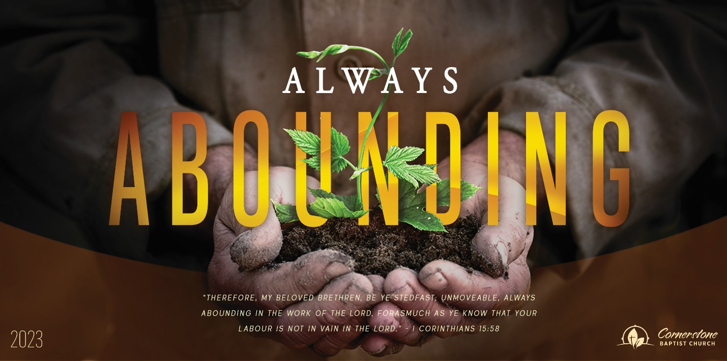
Sunday September 3, 2023

All Day Long

Cornerstone Baptist Church
315 Shoup Ave. West
Twin Falls Id 83301
208-733-5312 cbctwinfalls.com

All Day Long
Romans 10:17-21

Introduction:

- The Need to ________________________. Vs. 16
  - Obey the gospel.
  - Believe the report.
- The Need to _______________________. Vs. 18
  - Sound went out.
  - Sound still goes out.
- The Need to _________________________. Vs. 19
  - Knowledge is important.
  - Knowledge stirred up.
  - Knowledge pricking the heart.
- The Need to ____________________________. Vs. 21
  - Going to an unknown group.
  - Going to a rejecting group.
  - A merciful God.
  - A persevering God.
  - A loving God.

Conclusion:

Sunday September 3, 2023

All Day Long

Cornerstone Baptist Church
315 Shoup Ave. West
Twin Falls Id 83301
208-733-5312 cbctwinfalls.com

All Day Long
Romans 10:17-21

Introduction:

- The Need to ________________________. Vs. 16
  - Obey the gospel.
  - Believe the report.
- The Need to _______________________. Vs. 18
  - Sound went out.
  - Sound still goes out.
- The Need to _________________________. Vs. 19
  - Knowledge is important.
  - Knowledge stirred up.
  - Knowledge pricking the heart.
- The Need to ____________________________. Vs. 21
  - Going to an unknown group.
  - Going to a rejecting group.
  - A merciful God.
  - A persevering God.
  - A loving God.

Conclusion:

