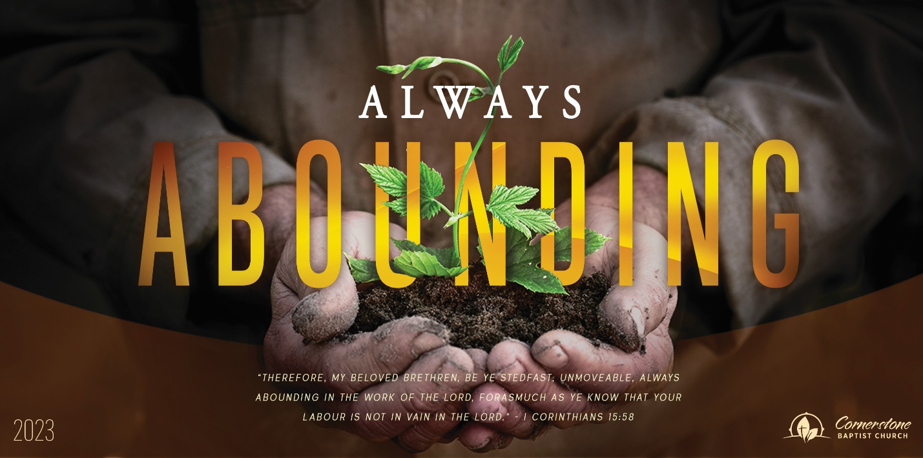
Provision in Emptiness
1 Kings 17:2-16

Sunday Night, August 13, 2023
Cornerstone Baptist Church
315 Shoup Ave. West
Twin Falls Id 83301
208-733-5312 cbctwinfalls.com

Provision in Emptiness
1 Kings 17:2-16
Introduction:

- A Dry _________________, A Refreshing ___________________.
  - The land became empty for everyone.
  - The land became empty because of Elijah praying.
  - The land affected Elijah also.
  - The land provided an effective spring for Elijah.
- An End of a _________________, A Refreshing _______________.
  - The provided for trickle disappeared.
  - The question of provision was real.
  - The direction came from a trusted source.
- A __________________ Person, An Amazing ________________.
  - The widow became the source.
  - The test for her was challenging.
  - Her faith was unwavering.
- An Empty ________________, A Continual __________________.
  - A barrel of meal and a cruse of oil.
  - A consistent miraculous filling.
  - It shouldn’t have lasted, but it did!

Conclusion:
- God ____________________ one step at a time.
- There is power in the _______________________ life.
- God was at work at _______________ (cutting away). The ravens fed him there (specifically, as if there was a pull elsewhere).
- Our ___________ in God’s Word will test other’s ______________ in God’s Word.
- God _________________ enough each day.
Provision in Emptiness
1 Kings 17:2-16

Sunday Night, August 13, 2023
Cornerstone Baptist Church
315 Shoup Ave. West
Twin Falls Id 83301
208-733-5312 cbctwinfalls.com

Provision in Emptiness
1 Kings 17:2-16
Introduction:

- A Dry _________________, A Refreshing ___________________.
  - The land became empty for everyone.
  - The land became empty because of Elijah praying.
  - The land affected Elijah also.
  - The land provided an effective spring for Elijah.
- An End of a _________________, A Refreshing _______________.
  - The provided for trickle disappeared.
  - The question of provision was real.
  - The direction came from a trusted source.
- A __________________ Person, An Amazing ________________.
  - The widow became the source.
  - The test for her was challenging.
  - Her faith was unwavering.
- An Empty ________________, A Continual __________________.
  - A barrel of meal and a cruse of oil.
  - A consistent miraculous filling.
  - It shouldn’t have lasted, but it did!

Conclusion:
- God ____________________ one step at a time.
- There is power in the _______________________ life.
- God was at work at _______________ (cutting away). The ravens fed him there (specifically, as if there was a pull elsewhere).
- Our ___________ in God’s Word will test other’s ______________ in God’s Word.
- God _________________ enough each day.

