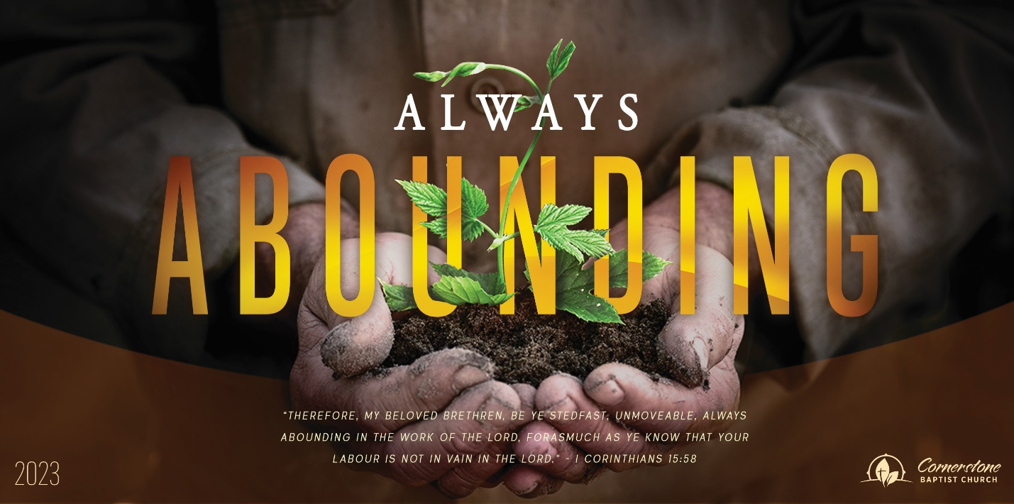
Sunday August 20, 2023

My Heart’s Desire

Cornerstone Baptist Church
315 Shoup Ave. West
Twin Falls Id 83301
208-733-5312 cbctwinfalls.com

My Heart’s Desire
Romans 10:1-15
Introduction:
1Ti 2:4-6

- The __________________ of the _______________. Vss. 2-6
Gal 1:13-14
  - Zeal. (2)
  - God’s righteousness. (3)
  - Christ’s sufficiency. (4)
  - The Law. (5)
- The ____________________ of the _______ _______. Vss. 6-10
  - Righteousness by faith. (6)
  - Word of Faith. Vs. 8
  - Confess with thy mouth. (9)
  - Believe in thy heart. (10)
- The _________________ of ___________________. Vss. 11-13
This is one area anyone can win at!
  - Whosoever believes. (11)
  - No difference. (12)
  - A real call.
- The _____________________ of _________________. Vss. 14-15
  - Belief to calling.
  - Hearing to believing.
  - Preaching to hearing.
  - Sending to preaching.

Conclusion:

Sunday August 20, 2023

My Heart’s Desire

Cornerstone Baptist Church
315 Shoup Ave. West
Twin Falls Id 83301
208-733-5312 cbctwinfalls.com

My Heart’s Desire
Romans 10:1-15
Introduction:
1Ti 2:4-6

- The __________________ of the _______________. Vss. 2-6
Gal 1:13-14
  - Zeal. (2)
  - God’s righteousness. (3)
  - Christ’s sufficiency. (4)
  - The Law. (5)
- The ____________________ of the _______ _______. Vss. 6-10
  - Righteousness by faith. (6)
  - Word of Faith. Vs. 8
  - Confess with thy mouth. (9)
  - Believe in thy heart. (10)
- The _________________ of ___________________. Vss. 11-13
This is one area anyone can win at!
  - Whosoever believes. (11)
  - No difference. (12)
  - A real call.
- The _____________________ of _________________. Vss. 14-15
  - Belief to calling.
  - Hearing to believing.
  - Preaching to hearing.
  - Sending to preaching.

Conclusion:

