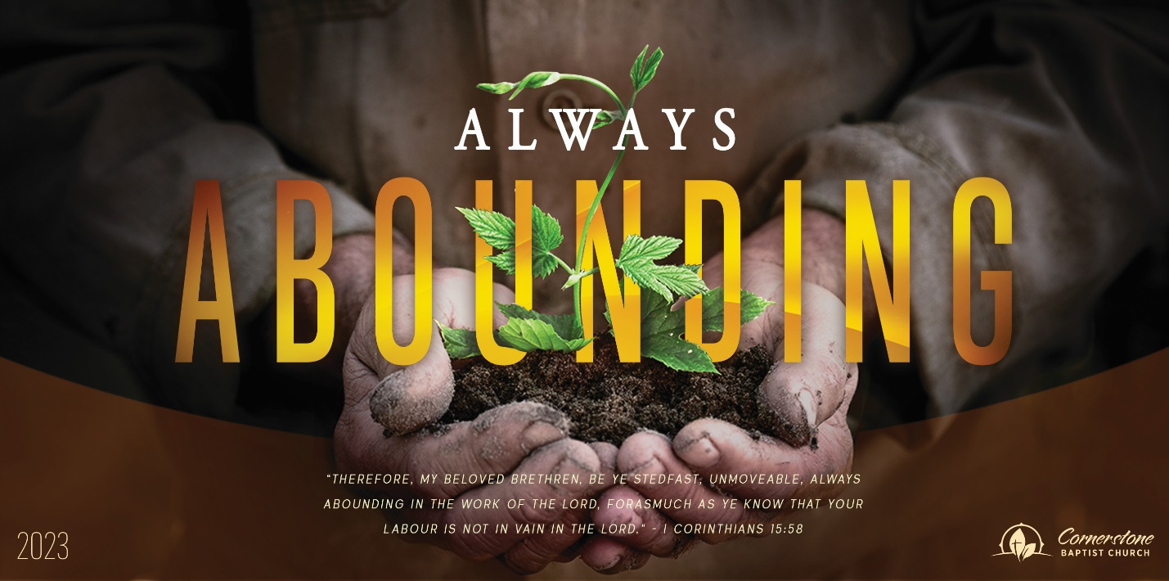
Sunday August 6, 2023

A Real Burden

Cornerstone Baptist Church
315 Shoup Ave. West
Twin Falls Id 83301
208-733-5312 cbctwinfalls.com

Effective or Ineffective
Romans 9:6-33
Introduction:

- The ___________________________ of God. Vss. 7-9
  - To the believer.
  - To Israel.

- The ___________________________ of God.
  - A Just God. 9-13
  - A righteous God. Vs. 14
  - Merciful and compassionate God. Vs. 15
    - Matt. 20:1-16
  - A purposeful God. Vs. 17
  - An all-powerful and all-knowing God.
Rom 9:20-21

- The ___________________________ of God.
  - All people.
  - All the unknown.

- The ____________________________ of God.
  - Righteousness by faith for all.
  - Righteousness through the Messiah only.
  - Righteousness is a stumbling stone for many.

Conclusion:

Sunday August 13, 2023

Effective or Ineffective

Cornerstone Baptist Church
315 Shoup Ave. West
Twin Falls Id 83301
208-733-5312 cbctwinfalls.com

Effective or Ineffective
Romans 9:6-33
Introduction:

- The ___________________________ of God. Vss. 7-9
  - To the believer.
  - To Israel.

- The ___________________________ of God.
  - A Just God. 9-13
  - A righteous God. Vs. 14
  - Merciful and compassionate God. Vs. 15
    - Matt. 20:1-16
  - A purposeful God. Vs. 17
  - An all-powerful and all-knowing God.
Rom 9:20-21

- The ___________________________ of God.
  - All people.
  - All the unknown.

- The ____________________________ of God.
  - Righteousness by faith for all.
  - Righteousness through the Messiah only.
  - Righteousness is a stumbling stone for many.

Conclusion:

