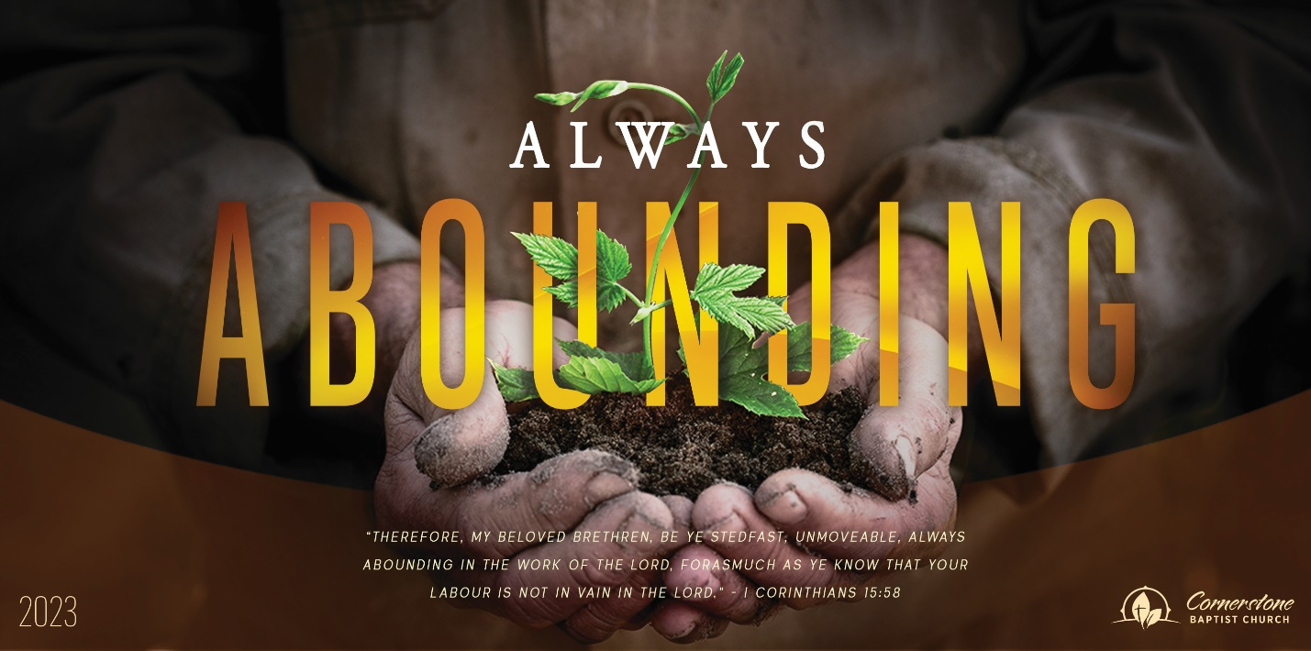
Sunday August 6, 2023

A Real Burden

Cornerstone Baptist Church
315 Shoup Ave. West
Twin Falls Id 83301
208-733-5312 cbctwinfalls.com

A Real Burden
Romans 9:1-5
Introduction:
Gal 6:2; Mat 11:28-30
- Burden of anxiety.
- Burden of guilt.
- Burden of failure.
- Burden of injustice.

- A Spiritual ____________________________.
Rom 1:14-15
  - Spiritual Christians
  - Honorable Christians.
  - Faithful Christians.
  - Obedient Christians.
  - Generous Christians.
- A Spiritual ____________________________.
    - The need of truth. Joh 17:17-18
    - The need of grace. Tit 2:11-12; 1Ti 1:12-14
    - The need of sight. Luk 19:3; Joh 6:19 nigh unto the ship: and they were afraid. Heb 2:9-10
    - The need of the gospel. 1Co 15:1-4
- A Spiritually ________________ Yet ___________________.
    - Israelites. Gen 32:28; Deu 7:6-8
    - Adoption. Gal 4:5
    - Glory. Exo 16:10
    - Covenants. Heb 12:24-25
    - Law. Joh 1:17
    - Service of God. Heb 9:3-9
    - Genealogy of Jesus. 2Ti 2:7-8 8

Conclusion:
Mat 9:35-38
Sunday August 6, 2023

A Real Burden

Cornerstone Baptist Church
315 Shoup Ave. West
Twin Falls Id 83301
208-733-5312 cbctwinfalls.com

A Real Burden
Romans 9:1-5
Introduction:
Gal 6:2; Mat 11:28-30
- Burden of anxiety.
- Burden of guilt.
- Burden of failure.
- Burden of injustice.

- A Spiritual ____________________________.
Rom 1:14-15
  - Spiritual Christians
  - Honorable Christians.
  - Faithful Christians.
  - Obedient Christians.
  - Generous Christians.
- A Spiritual ____________________________.
    - The need of truth. Joh 17:17-18
    - The need of grace. Tit 2:11-12; 1Ti 1:12-14
    - The need of sight. Luk 19:3; Joh 6:19 nigh unto the ship: and they were afraid. Heb 2:9-10
    - The need of the gospel. 1Co 15:1-4
- A Spiritually ________________ Yet ___________________.
    - Israelites. Gen 32:28; Deu 7:6-8
    - Adoption. Gal 4:5
    - Glory. Exo 16:10
    - Covenants. Heb 12:24-25
    - Law. Joh 1:17
    - Service of God. Heb 9:3-9
    - Genealogy of Jesus. 2Ti 2:7-8 8

Conclusion:
Mat 9:35-38

