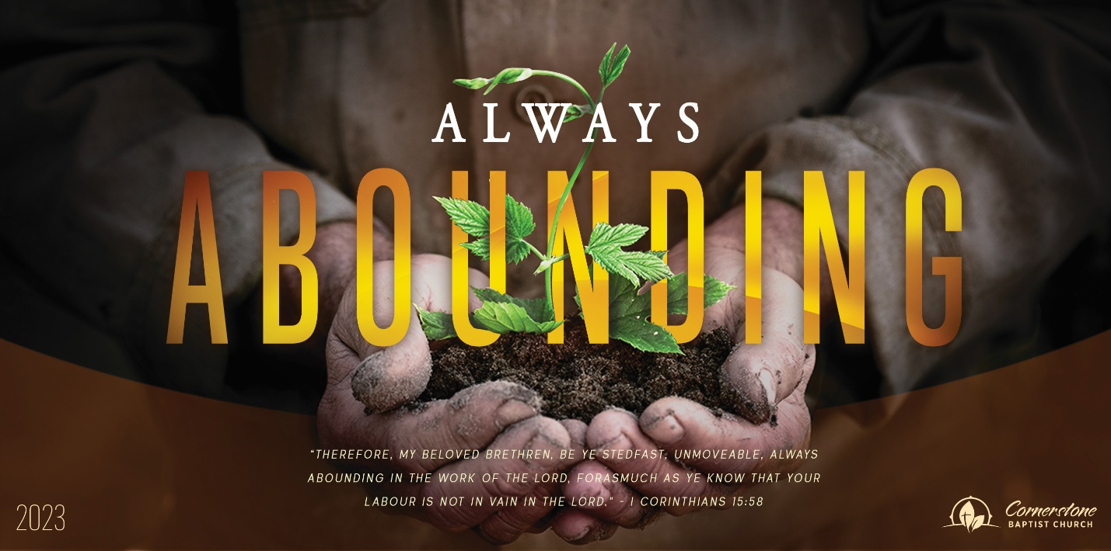

315 Shoup Ave. West
Twin Falls Id 83301
208-733-5312 cbctwinfalls.com

A Difficult Situation
Genesis 29:31-35; 30:1-24

Introduction:
7. Gad (Zilpah): “good fortune”
8. Asher (Zilpah): “happy”
9. Issachar (Leah): “man of hire”
10. Zebulun (Leah): “dwelling”
11. Joseph (Rachel): “may God add”
12. Benjamin (Rachel): “son of the right hand”

1. Reuben (Leah): “behold a son”
2. Simeon(Leah): “God hears”
3. Levi (Leah): “joined”
4. Judah (Leah): “let him [God] be praised”
5. Dan (Bilhah): “judge”
6. Naphtali (Bilhah): “my wrestling”

Gen 29:31, Gen 30:1
- Insecurity develops unhealthy _______________________.
- Insecurity develops ___________________________.
- Insecurity develops _______________________.
- Insecurity seeks ________________________.
- Insecurity leads to inner _________________________.
- Insecurity leads to __________________________.
- Insecurity leads to inner and outward suffering.
- _________________ my sin/problem of insecurity.
- _________________ my value in Christ.
  - Php 3:7-14
- _________________ my knowledge to my belief/reality.
  - Luk 6:46; Isa 29:13
- _________________ carefully due to our understanding of our sin nature.
  - Rom 7:18; Heb 4:13
- ___________________ yourself who you are in Christ.
  - Forgiven: Colossians 1:14
  - Adopted: Ephesians 1:5; 2:19; Romans 8:17
  - God is at work: Romans 8:28
  - Useful: 1 Corinthians 1:27–31; 2 Corinthians 12:9–10
  - Chosen: 1 Corinthians 12:18
Conclusion:

- You will find forgiveness not condemnation. Joh 8:10; 2Co 5:21
- Rest is available for your weary mind and stormy heart. Mat 11:28 .
- His love for you will not fail. Psa 103:17
- I can give you peace that passes understanding. Php 4:6-7
- I will be your security passed anything you have ever known. Psa 27:5; Psa 40:2

315 Shoup Ave. West
Twin Falls Id 83301
208-733-5312 cbctwinfalls.com

A Difficult Situation
Genesis 29:31-35; 30:1-24

Introduction:
7. Gad (Zilpah): “good fortune”
8. Asher (Zilpah): “happy”
9. Issachar (Leah): “man of hire”
10. Zebulun (Leah): “dwelling”
11. Joseph (Rachel): “may God add”
12. Benjamin (Rachel): “son of the right hand”

1. Reuben (Leah): “behold a son”
2. Simeon(Leah): “God hears”
3. Levi (Leah): “joined”
4. Judah (Leah): “let him [God] be praised”
5. Dan (Bilhah): “judge”
6. Naphtali (Bilhah): “my wrestling”

Gen 29:31, Gen 30:1
- Insecurity develops unhealthy _______________________.
- Insecurity develops ___________________________.
- Insecurity develops _______________________.
- Insecurity seeks ________________________.
- Insecurity leads to inner _________________________.
- Insecurity leads to __________________________.
- Insecurity leads to inner and outward suffering.
- _________________ my sin/problem of insecurity.
- _________________ my value in Christ.
  - Php 3:7-14
- _________________ my knowledge to my belief/reality.
  - Luk 6:46; Isa 29:13
- _________________ carefully due to our understanding of our sin nature.
  - Rom 7:18; Heb 4:13
- ___________________ yourself who you are in Christ.
  - Forgiven: Colossians 1:14
  - Adopted: Ephesians 1:5; 2:19; Romans 8:17
  - God is at work: Romans 8:28
  - Useful: 1 Corinthians 1:27–31; 2 Corinthians 12:9–10
  - Chosen: 1 Corinthians 12:18
Conclusion:

- You will find forgiveness not condemnation. Joh 8:10; 2Co 5:21
- Rest is available for your weary mind and stormy heart. Mat 11:28 .
- His love for you will not fail. Psa 103:17
- I can give you peace that passes understanding. Php 4:6-7
- I will be your security passed anything you have ever known. Psa 27:5; Psa 40:2

