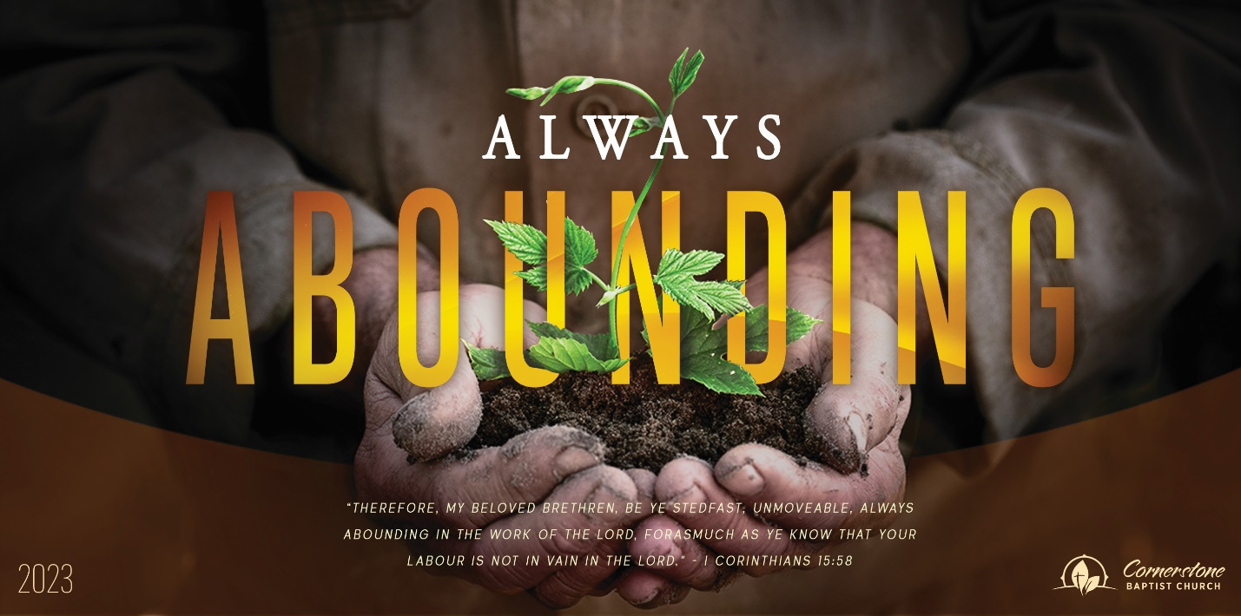
Sunday July 30, 2023

Real Confidence

Cornerstone Baptist Church
315 Shoup Ave. West
Twin Falls Id 83301
208-733-5312 cbctwinfalls.com

Real Confidence
Romans 8:18-30
Introduction:

- The Confidence of God’s __________________. Vss. 31-32
  - God’s promise. 2Co 1:20; 2Pe 1:4
  - God’s proof. Rom 8:15; 2Ti 1:7; Psa 118:6; Act 2:21-24

- The Confidence of God’s ____________________. Vss. 33-34
  - A cleansed Christian.
  - A justified Christian.
  - A loved Christian.
Zec 3:1-5; 1Co 6:9-11

- The Confidence of God’s __________________. Vss. 35-36
  - We have trials.
  - We have grace.
  - We have hope.
Act 10:42-43; 1Jn 4:9-10; Rev 7:9-17

- The Confidence of God’s ____________________. Vss. 37-39
  - Persuaded by our salvation.
  - Persuaded by his character.
  - Persuaded by my position.
Rom 4:21; Php 1:6; Tit 3:4-6

Conclusion:

Sunday July 30, 2023

Real Confidence

Cornerstone Baptist Church
315 Shoup Ave. West
Twin Falls Id 83301
208-733-5312 cbctwinfalls.com

Real Confidence
Romans 8:18-30
Introduction:

- The Confidence of God’s __________________. Vss. 31-32
  - God’s promise. 2Co 1:20; 2Pe 1:4
  - God’s proof. Rom 8:15; 2Ti 1:7; Psa 118:6; Act 2:21-24

- The Confidence of God’s ____________________. Vss. 33-34
  - A cleansed Christian.
  - A justified Christian.
  - A loved Christian.
Zec 3:1-5; 1Co 6:9-11

- The Confidence of God’s __________________. Vss. 35-36
  - We have trials.
  - We have grace.
  - We have hope.
Act 10:42-43; 1Jn 4:9-10; Rev 7:9-17

- The Confidence of God’s ____________________. Vss. 37-39
  - Persuaded by our salvation.
  - Persuaded by his character.
  - Persuaded by my position.
Rom 4:21; Php 1:6; Tit 3:4-6

Conclusion:

