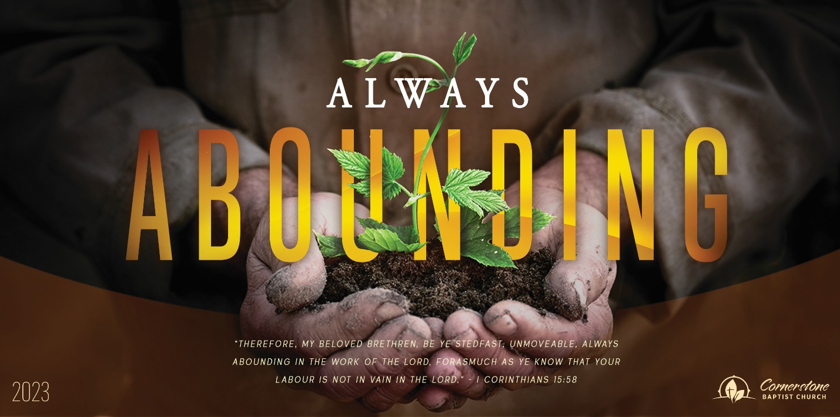
Sunday July 9, 2023

A Secure Family

Cornerstone Baptist Church
315 Shoup Ave. West
Twin Falls Id 83301
208-733-5312 cbctwinfalls.com

A Secure Family
Romans 8:12-17
Introduction:

- The ________________________ of the Holy Spirit.
  - Led to a right attitude.
  - Led to mortify the sinful flesh. Gal. 3:3
  - Led to a place of confidence.

- The ________________________ of the Holy Spirit.
  - Adopted to security.
  - Adopted to love-relationship.
- The ________________________ of the Holy Spirit.
  - An inner persuasion.
  - An inner confidence.
- The ________________________ of the Holy Spirit. Luke 18:18
  - An heir of God.
  - A joint heir with Jesus Christ.
  - A connection now with reward later.

Conclusion:

Sunday July 9, 2023

A Secure Family

Cornerstone Baptist Church
315 Shoup Ave. West
Twin Falls Id 83301
208-733-5312 cbctwinfalls.com

A Secure Family
Romans 8:12-17
Introduction:

- The ________________________ of the Holy Spirit.
  - Led to a right attitude.
  - Led to mortify the sinful flesh. Gal. 3:3
  - Led to a place of confidence.

- The ________________________ of the Holy Spirit.
  - Adopted to security.
  - Adopted to love-relationship.
- The ________________________ of the Holy Spirit.
  - An inner persuasion.
  - An inner confidence.
- The ________________________ of the Holy Spirit. Luke 18:18
  - An heir of God.
  - A joint heir with Jesus Christ.
  - A connection now with reward later.

Conclusion:

