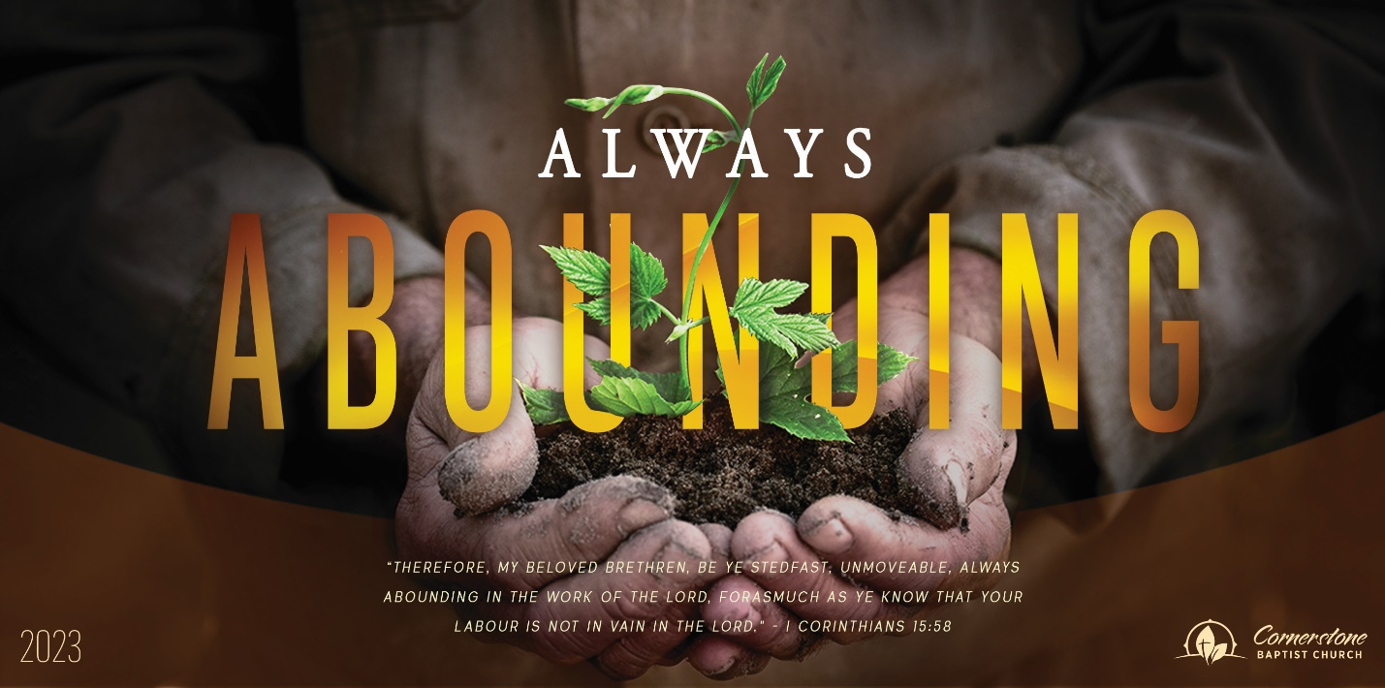
Sunday June 4, 2023

Who Represents You?

Cornerstone Baptist Church
315 Shoup Ave. West
Twin Falls Id 83301
208-733-5312 cbctwinfalls.com

Who Represents You?
Romans 5:12-21
Introduction:

- The Entrance of ________________________.
Jas 1:13-16
  - The reign of the law.
  - The reign of sin. Gen. 5:3

- The Entrance of ________________________.
  - Grace as a gift.
  - Grace as provided.
  - Grace as abundant.

- The Entrance of _______________________.
  - Life by One.
  - Gift by One.
  - Righteousness by One.

Conclusion:

Sunday June 4, 2023

Who Represents You?

Cornerstone Baptist Church
315 Shoup Ave. West
Twin Falls Id 83301
208-733-5312 cbctwinfalls.com

Who Represents You?
Romans 5:12-21
Introduction:

- The Entrance of ________________________.
Jas 1:13-16
  - The reign of the law.
  - The reign of sin. Gen. 5:3

- The Entrance of ________________________.
  - Grace as a gift.
  - Grace as provided.
  - Grace as abundant.

- The Entrance of _______________________.
  - Life by One.
  - Gift by One.
  - Righteousness by One.

Conclusion:

