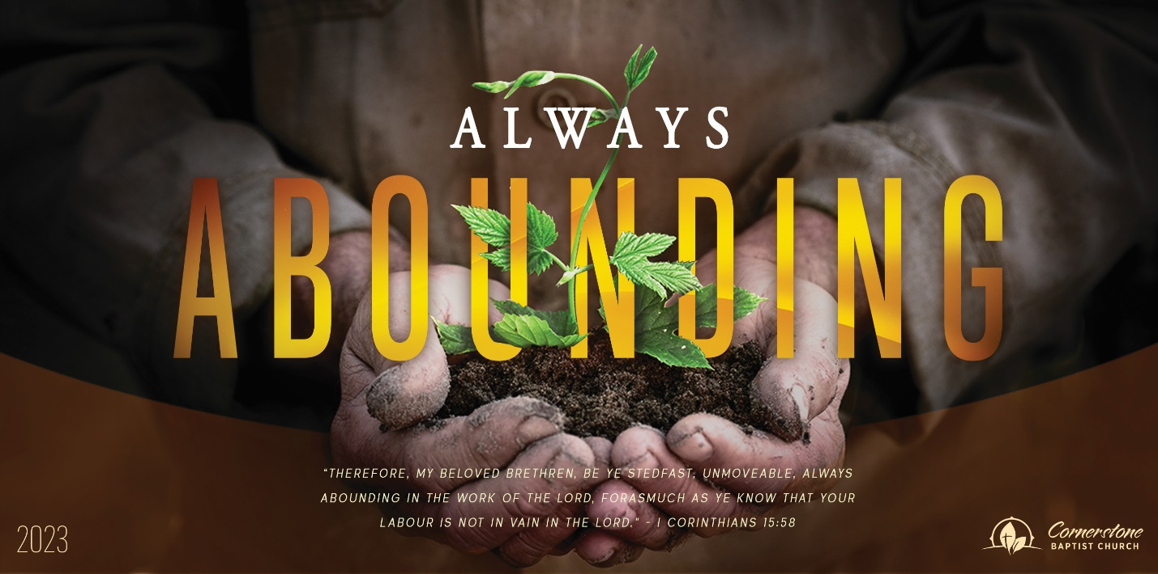
Sunday June 18, 2023

What Kind of Life Does Your Instrument Play?

Cornerstone Baptist Church
315 Shoup Ave. West
Twin Falls Id 83301
208-733-5312 cbctwinfalls.com

What Kind of Life Does Your Instrument Play?
Romans 6:12-23
Introduction:
1Co 9:25-27

- A Question of _______________________. Vss. 13-16
  - The Spirit in us.
  - The Spirit leading us.
Gal 2:20-21

- A Question of ___________________________. Vss. 17-19
Jer 29:13; Heb 11:24-25; Tit 2:11-12
  - A liberty.
  - A loyalty.

- A Question of __________________________. Vss. 20-23
Gal 6:7-9
  - A new attitude.
  - A new value.
  - A new life.

Conclusion:
Rom 6:23 For the wages of sin is death; but the gift of God is eternal life through Jesus Christ our Lord.

______________________ of the old master.
______________________ from the old master.
______________________ of the new master.
______________________ of the new life.

Sunday June 18, 2023

What Kind of Life Does Your Instrument Play?

Cornerstone Baptist Church
315 Shoup Ave. West
Twin Falls Id 83301
208-733-5312 cbctwinfalls.com

What Kind of Life Does Your Instrument Play?
Romans 6:12-23
Introduction:
1Co 9:25-27

- A Question of _______________________. Vss. 13-16
  - The Spirit in us.
  - The Spirit leading us.
Gal 2:20-21

- A Question of ___________________________. Vss. 17-19
Jer 29:13; Heb 11:24-25; Tit 2:11-12
  - A liberty.
  - A loyalty.

- A Question of __________________________. Vss. 20-23
Gal 6:7-9
  - A new attitude.
  - A new value.
  - A new life.

Conclusion:
Rom 6:23 For the wages of sin is death; but the gift of God is eternal life through Jesus Christ our Lord.

______________________ of the old master.
______________________ from the old master.
______________________ of the new master.
______________________ of the new life.

