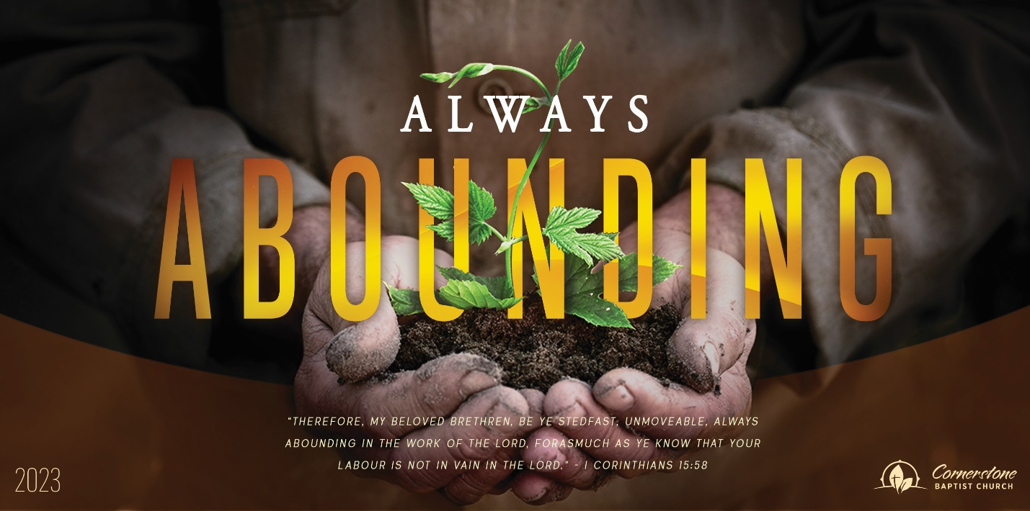
A Little Maid
Sunday, June 4, 2023

Cornerstone Baptist Church
315 Shoup Ave. West Twin Falls, ID 83301
cbctwinfalls.com 208-733-5312

A Little Maid
2 Kings 5

Introduction:
Zec 4:10; Est 2:7
- An _______________________________ Child.
1Ti 6:1; Eph 6:7-8; Psa 123:2
  - Faithful to her mission.
  - Faithful to her raising.
  - Faithful to her family.
  - Faithful to her God.
Act 26:28-29

- An ____________________________ Child.
Luk 23:8; Rom 1:16-17
  - Observant of the need.
  - Observant of the miracle required.
  - Observant of the potential.
- An ___________________________ Child.
  - She took advantage of a difficult situation.
  - She overcame the inner spiritual battle.
  - She had a continued attitude of hope.
  - She was willing to help all people.

Conclusion:

A Little Maid
Sunday, June 4, 2023

Cornerstone Baptist Church
315 Shoup Ave. West Twin Falls, ID 83301
cbctwinfalls.com 208-733-5312

A Little Maid
2 Kings 5

Introduction:
Zec 4:10; Est 2:7
- An _______________________________ Child.
1Ti 6:1; Eph 6:7-8; Psa 123:2
  - Faithful to her mission.
  - Faithful to her raising.
  - Faithful to her family.
  - Faithful to her God.
Act 26:28-29

- An ____________________________ Child.
Luk 23:8; Rom 1:16-17
  - Observant of the need.
  - Observant of the miracle required.
  - Observant of the potential.
- An ___________________________ Child.
  - She took advantage of a difficult situation.
  - She overcame the inner spiritual battle.
  - She had a continued attitude of hope.
  - She was willing to help all people.

Conclusion:

