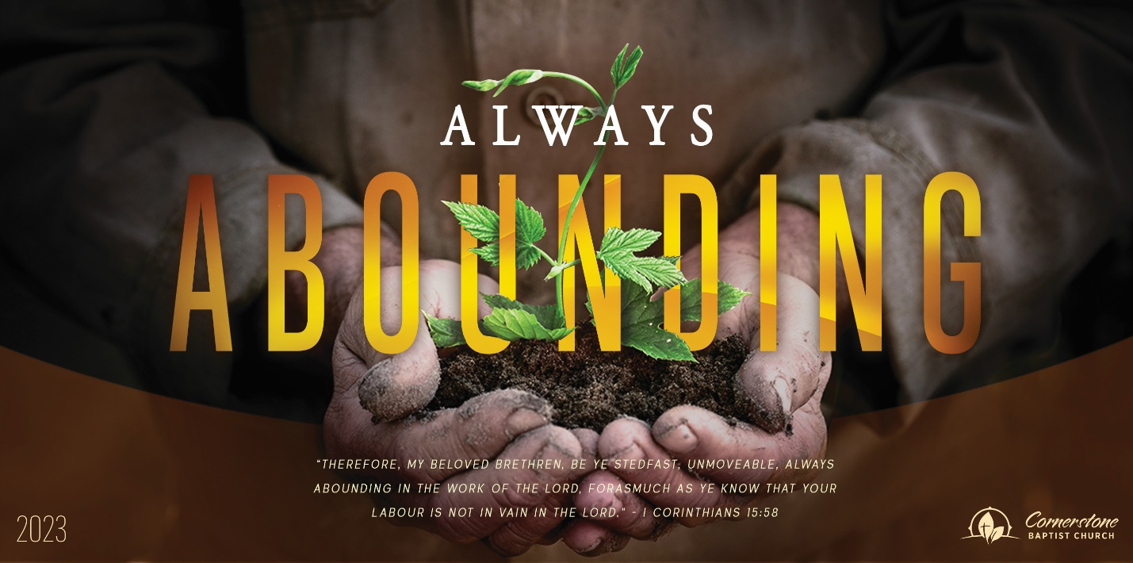

A Father’s Mission
June 18, 2023

Cornerstone Baptist Church
315 Shoup Ave. West Twin Falls, ID 83301
cbctwinfalls.com 208-733-5312

A Father’s Mission
Genesis 18:19
Intro:
Gen 18:18; Pro 6:20-23; Pro 4:1; Pro 5:1-2; Pro 2:1

- To Be Known By ___________________________. Gen 18:19
  - Registered in the book. Rev. 20:15
  - Recognizable name. 2 Sa,/ 7:20-21
  - Regular visits. Ex. 33:12-13
- To Be Known By His ________________________.
  - A teacher. 2 Tim. 3:15
  - A builder Eph. 6:4
  - An example 1 Thess. 2:11-12
  - A protector. Prov. 4:4
  - A catalyst. Mal. 4:6; Luke 1:17

- To Be Known to Be in _______________ ____________.
  - Trustworthy of God’s blessings. Psalm 1:5-6
  - Prayers are heard of God. Psalm 34:14-15
  - Rejoices in the Lord. Psalm 40:16-17

Conclusion:

Joh 10:14; Joh 21:17; 2Ti 2:19

A Father’s Mission
June 18, 2023

Cornerstone Baptist Church
315 Shoup Ave. West Twin Falls, ID 83301
cbctwinfalls.com 208-733-5312

A Father’s Mission
Genesis 18:19
Intro:
Gen 18:18; Pro 6:20-23; Pro 4:1; Pro 5:1-2; Pro 2:1

- To Be Known By ___________________________. Gen 18:19
  - Registered in the book. Rev. 20:15
  - Recognizable name. 2 Sa,/ 7:20-21
  - Regular visits. Ex. 33:12-13
- To Be Known By His ________________________.
  - A teacher. 2 Tim. 3:15
  - A builder Eph. 6:4
  - An example 1 Thess. 2:11-12
  - A protector. Prov. 4:4
  - A catalyst. Mal. 4:6; Luke 1:17

- To Be Known to Be in _______________ ____________.
  - Trustworthy of God’s blessings. Psalm 1:5-6
  - Prayers are heard of God. Psalm 34:14-15
  - Rejoices in the Lord. Psalm 40:16-17

Conclusion:

Joh 10:14; Joh 21:17; 2Ti 2:19

