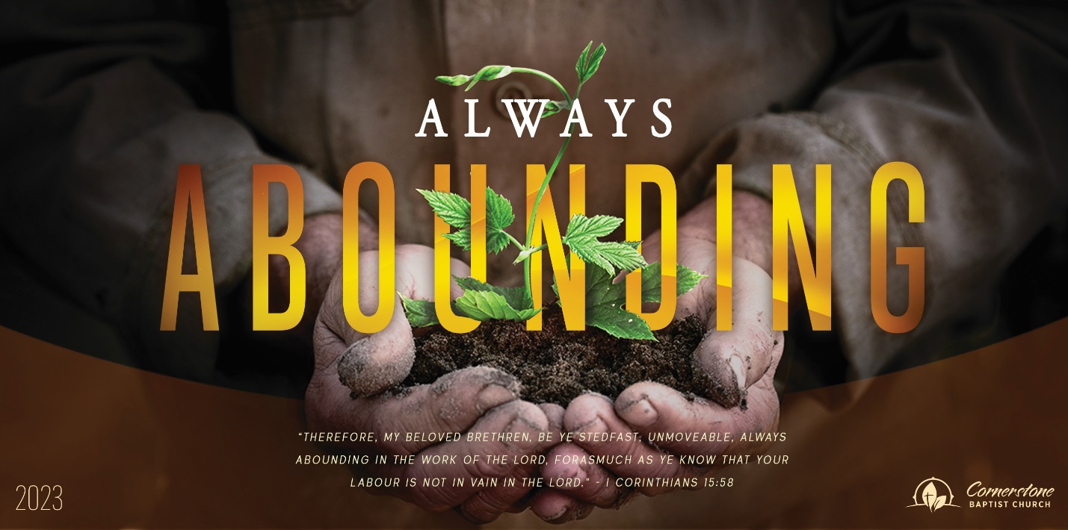
Sunday May 28, 2023

Peace with God

Cornerstone Baptist Church
315 Shoup Ave. West
Twin Falls Id 83301
208-733-5312 cbctwinfalls.com

Peace with God
Romans 5:1-11
Introduction:
Isa 1:18; 1Jn 3:19-21; Heb 6:1

- __________________ with God. Col. 3:15
- ___________________ to God. Eph. 3:12; Acts 13:43; Titus 2:11-13
- ___________________ in God. Phil. 1:6
- ___________________ in God.
  - Proof of his love.
  - Unconditional love.
  - Active love.
- __________________ to God.
  - God didn’t need to be reconciled to us, we needed to be reconciled to him!
  - The extent to which God went to reach us.
  - His death paid the price, his life insured the gift.
- ___________________ in God.
  - Joy in freedom.
  - Joy in forgiveness.
  - Joy in liberty from sin.
  - Joy in hope.
  - Joy in peace.
  - Joy in right standing with God.
Conclusion:

Sunday May 28, 2023

Peace with God

Cornerstone Baptist Church
315 Shoup Ave. West
Twin Falls Id 83301
208-733-5312 cbctwinfalls.com

Peace with God
Romans 5:1-11
Introduction:
Isa 1:18; 1Jn 3:19-21; Heb 6:1

- __________________ with God. Col. 3:15
- ___________________ to God. Eph. 3:12; Acts 13:43; Titus 2:11-13
- ___________________ in God. Phil. 1:6
- ___________________ in God.
  - Proof of his love.
  - Unconditional love.
  - Active love.
- __________________ to God.
  - God didn’t need to be reconciled to us, we needed to be reconciled to him!
  - The extent to which God went to reach us.
  - His death paid the price, his life insured the gift.
- ___________________ in God.
  - Joy in freedom.
  - Joy in forgiveness.
  - Joy in liberty from sin.
  - Joy in hope.
  - Joy in peace.
  - Joy in right standing with God.
Conclusion:

