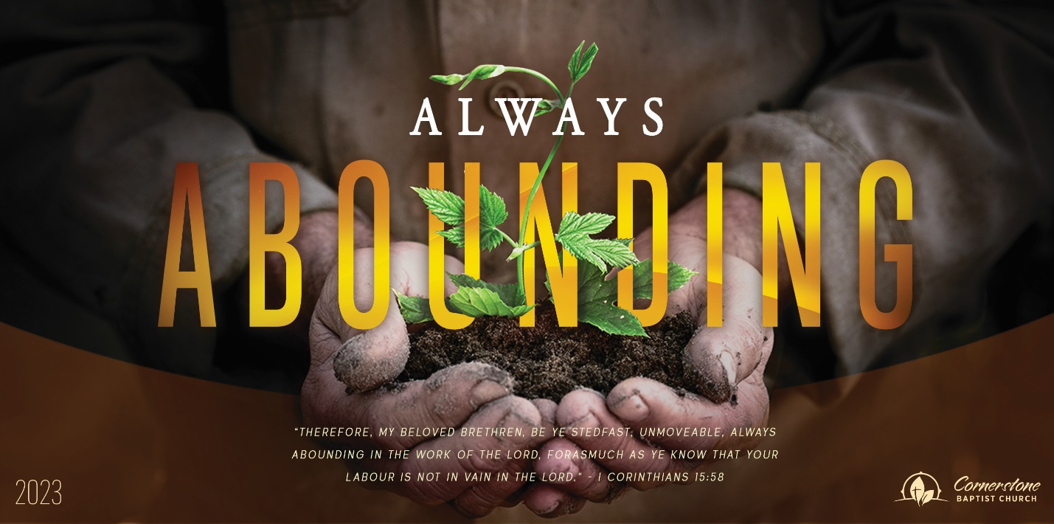
Sunday May 21, 2023

Faith Alone

Cornerstone Baptist Church
315 Shoup Ave. West
Twin Falls Id 83301
208-733-5312 cbctwinfalls.com

Faith Alone
Romans 4
Introduction:
- Two Examples of ________________________.
  - Abraham.
    - Belief=righteousness.
    - Work=debt.
  - David. Quote from Psalm 32
    - Happy is the man:
      - Forgiven.
      - Covered.
      - Debt is cleared.
- Two Illustrations of ______________________. Rom 4:14-15; Rom 11:6
  - Circumcision.
    - The act of removal of the flesh by personal action.
  - The Law.
    - The removal of sin by a code of ethics. Eph 2:8-9

- Two Positions of _______________________.
  - The promise fulfilled.
    - The inheritance of promise.
    - The inheritance of the gifts of God.
  - The imputed righteousness of God. Rom. 5:1
    - A promise for all who believe.
    - A justification for all who believe.

Conclusion:

Sunday May 21, 2023

Faith Alone

Cornerstone Baptist Church
315 Shoup Ave. West
Twin Falls Id 83301
208-733-5312 cbctwinfalls.com

Faith Alone
Romans 4
Introduction:
- Two Examples of ________________________.
  - Abraham.
    - Belief=righteousness.
    - Work=debt.
  - David. Quote from Psalm 32
    - Happy is the man:
      - Forgiven.
      - Covered.
      - Debt is cleared.
- Two Illustrations of ______________________. Rom 4:14-15; Rom 11:6
  - Circumcision.
    - The act of removal of the flesh by personal action.
  - The Law.
    - The removal of sin by a code of ethics. Eph 2:8-9

- Two Positions of _______________________.
  - The promise fulfilled.
    - The inheritance of promise.
    - The inheritance of the gifts of God.
  - The imputed righteousness of God. Rom. 5:1
    - A promise for all who believe.
    - A justification for all who believe.
Conclusion:

