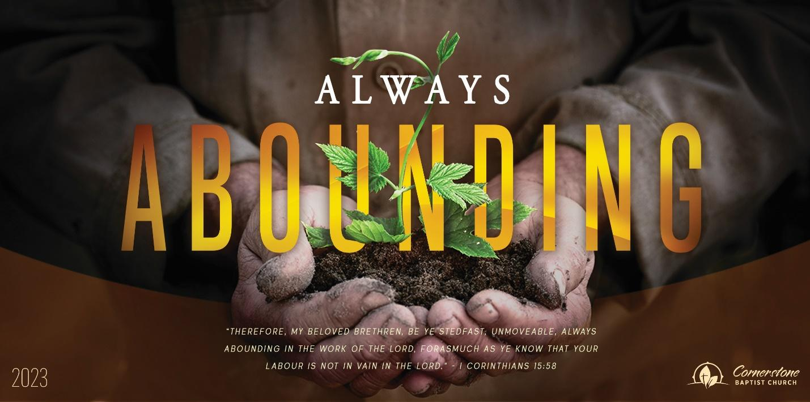

It Is Finished

John 19

Sunday, April 2, 2023

Cornerstone Baptist Church

315 Shoup Ave. West

Twin Falls Id 83301

208-733-5312 [cbctwinfalls.com](http://cbctwinfalls.com)

It Is Finished

John 19

Introduction:

There is something incredibly satisfying about finishing a job, project, or even stage of life.

1. The _________________________ is Finished. Heb. 9:12
2. The _________________________ is Finished. Heb. 9:13-14
3. The _________________________ is Finished. Heb. 9:15
4. The _________________________ is Finished. Heb. 9:28
5. The _________________ of the _______ was Finished. Heb. 10:10

Conclusion:

Rejoice in ________________. Heb. 10:19

_______________ near to God in ___________________. Heb. 10:22

Be _______________________ in our salvation. Heb. 10:23

___________________ each _______________. Heb. 10:24-25



It Is Finished

John 19

Sunday, April 2, 2023

Cornerstone Baptist Church

315 Shoup Ave. West

Twin Falls Id 83301

208-733-5312 [cbctwinfalls.com](http://cbctwinfalls.com)

It Is Finished

John 19

Introduction:

There is something incredibly satisfying about finishing a job, project, or even stage of life.

1. The _________________________ is Finished. Heb. 9:12
2. The _________________________ is Finished. Heb. 9:13-14
3. The _________________________ is Finished. Heb. 9:15
4. The _________________________ is Finished. Heb. 9:28
5. The _________________ of the _______ was Finished. Heb. 10:10

Conclusion:

Rejoice in ________________. Heb. 10:19

_______________ near to God in ___________________. Heb. 10:22

Be _______________________ in our salvation. Heb. 10:23

___________________ each _______________. Heb. 10:24-25