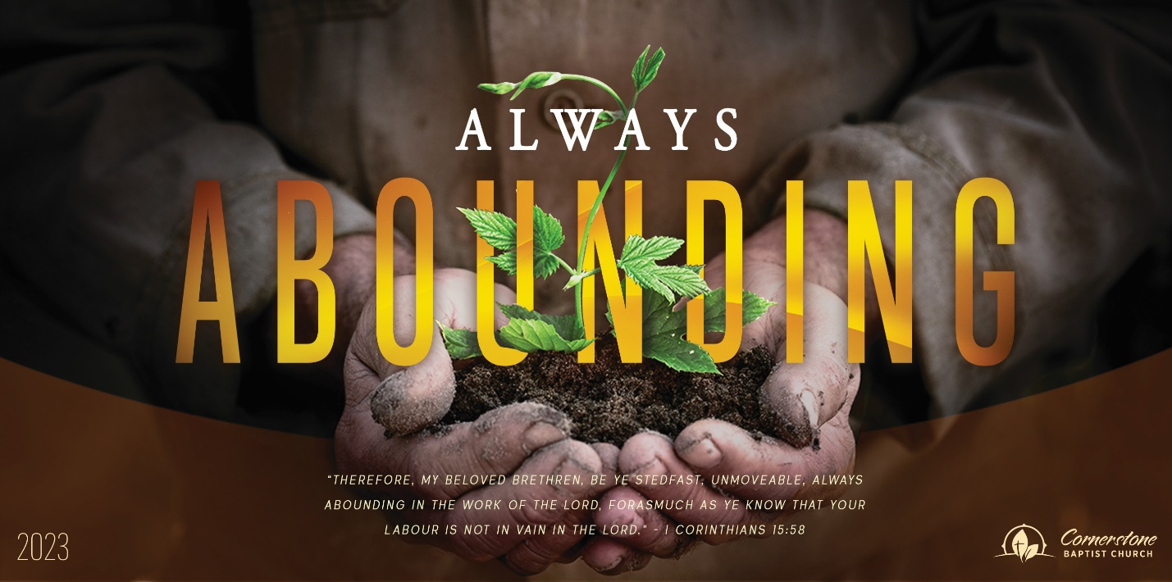
Israel’s Conflict
2 Chronicles 16:25-34

Sunday Night, April 23, 2023
Cornerstone Baptist Church
315 Shoup Ave. West
Twin Falls Id 83301
208-733-5312 cbctwinfalls.com

Israel’s Conflict
2 Chronicles 16:25-34
Introduction:
Pro 14:34 Righteousness exalteth a nation: but sin is a reproach to any people.

- A ___________________________ Man.
Pro 4:19; Pro 11:20; Pro 15:9-10 A dangerous life.
  - An unreasonable life.
  - A fearful life.

- An ___________________________ Man.
Pro 14:12 There is a way which seemeth right unto a man, but the end thereof are the ways of death.
The sin of man.
  - Hides from the soul the excessive wickedness of sin.
  - Renders the soul incapable of learning lessons from the most terrible punishments of sin.
  - Prevents the soul from seeing the danger and misery into which it is surely drifting.

- A ________________________ Man.
  - The use of the wicked does not mean they are no longer wicked.
  - Wicked used to judge the wicked.
    - 2Sa 24:14
Conclusion:
- The forbearance of God has its limits.
- A similar punishment to that which the wicked have inflicted on others may overtake themselves.
- A life of sin leads to misery and death.
Israel’s Conflict
2 Chronicles 16:25-34

Sunday Night, April 23, 2023
Cornerstone Baptist Church
315 Shoup Ave. West
Twin Falls Id 83301
208-733-5312 cbctwinfalls.com

Israel’s Conflict
2 Chronicles 16:25-34
Introduction:
Pro 14:34 Righteousness exalteth a nation: but sin is a reproach to any people.

- A ___________________________ Man.
Pro 4:19; Pro 11:20; Pro 15:9-10 A dangerous life.
  - An unreasonable life.
  - A fearful life.

- An ___________________________ Man.
Pro 14:12 There is a way which seemeth right unto a man, but the end thereof are the ways of death.
The sin of man.
  - Hides from the soul the excessive wickedness of sin.
  - Renders the soul incapable of learning lessons from the most terrible punishments of sin.
  - Prevents the soul from seeing the danger and misery into which it is surely drifting.

- A ________________________ Man.
  - The use of the wicked does not mean they are no longer wicked.
  - Wicked used to judge the wicked.
    - 2Sa 24:14
Conclusion:
- The forbearance of God has its limits.
- A similar punishment to that which the wicked have inflicted on others may overtake themselves.
- A life of sin leads to misery and death.

