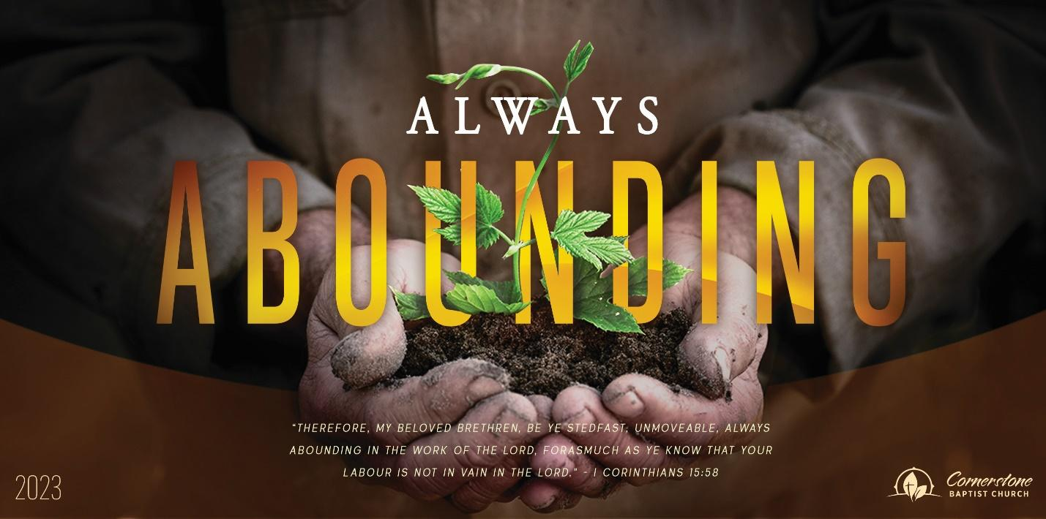

Behold the Man

John 19

Sunday, April 2, 2023

Cornerstone Baptist Church

315 Shoup Ave. West

Twin Falls Id 83301

208-733-5312 [cbctwinfalls.com](http://cbctwinfalls.com)

Behold the Man

John 19

Introduction:

1. The __________________________. Vs.1
2. The __________________________. Vs. 2
3. The __________________________. Vss. 3-7
4. The __________________________. Vss. 8-16
5. The __________________________. Vs.17
6. The __________________________. Vs.18
7. The __________________________. Vs.25
8. The __________________________. Vs.30-33

Conclusion:

Vs.35

Behold the _______________.

Behold the _______________.

Behold your ______________.



Behold the Man

John 19

Sunday, April 2, 2023

Cornerstone Baptist Church

315 Shoup Ave. West

Twin Falls Id 83301

208-733-5312 [cbctwinfalls.com](http://cbctwinfalls.com)

Behold the Man

John 19

Introduction:

1. The __________________________. Vs.1
2. The __________________________. Vs. 2
3. The __________________________. Vss. 3-7
4. The __________________________. Vss. 8-16
5. The __________________________. Vs.17
6. The __________________________. Vs.18
7. The __________________________. Vs.25
8. The __________________________. Vs.30-33

Conclusion:

Vs.35

Behold the _______________.

Behold the _______________.

Behold your ______________.