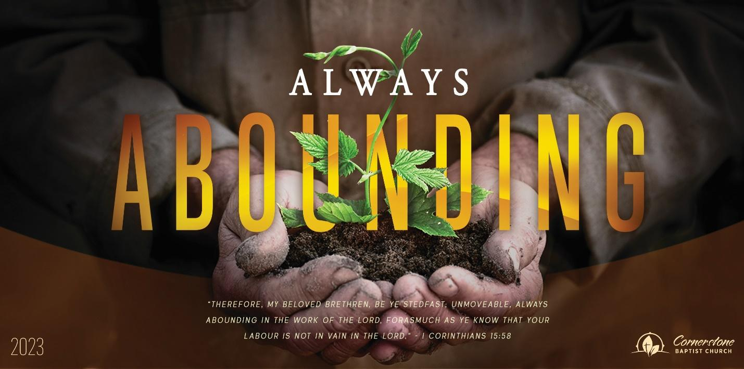

Trust in God’s Promises

Genesis 15

March 15, 2023

Cornerstone Baptist Church

315 Shoup Ave. West

Twin Falls Id 83301

208-733-5312 [cbctwinfalls.com](http://cbctwinfalls.com)

Trust in God’s Promises

Genesis 15

Introduction:

1. Trust in His ___________________. (1-4)

Psalm 22

* 1. A great shield
  2. A great reward.
  3. A great concern.
  4. A great response.

1. Trust in His __________________. (5-7)
   1. God’s ability to develop.
   2. God’s ability to give.
2. Trust in His __________________. (8-12) Titus 1:2
   1. The covenant

b. The condition. Heb.6:13

1. Trust in His __________________. (13-16)
   1. A stranger in the land.
   2. God will judge the nation.
   3. Abram would die in old age.
   4. Fourth generation released from Egypt.

Conclusion:



Trust in God’s Promises

Genesis 15

March 15, 2023

Cornerstone Baptist Church

315 Shoup Ave. West

Twin Falls Id 83301

208-733-5312 [cbctwinfalls.com](http://cbctwinfalls.com)

Trust in God’s Promises

Genesis 15

Introduction:

1. Trust in His ___________________. (1-4)

Psalm 22

* 1. A great shield
  2. A great reward.
  3. A great concern.
  4. A great response.

1. Trust in His __________________. (5-7)
   1. God’s ability to develop.
   2. God’s ability to give.
2. Trust in His __________________. (8-12) Titus 1:2
   1. The covenant

b. The condition. Heb.6:13

1. Trust in His __________________. (13-16)
   1. A stranger in the land.
   2. God will judge the nation.
   3. Abram would die in old age.
   4. Fourth generation released from Egypt.

Conclusion: