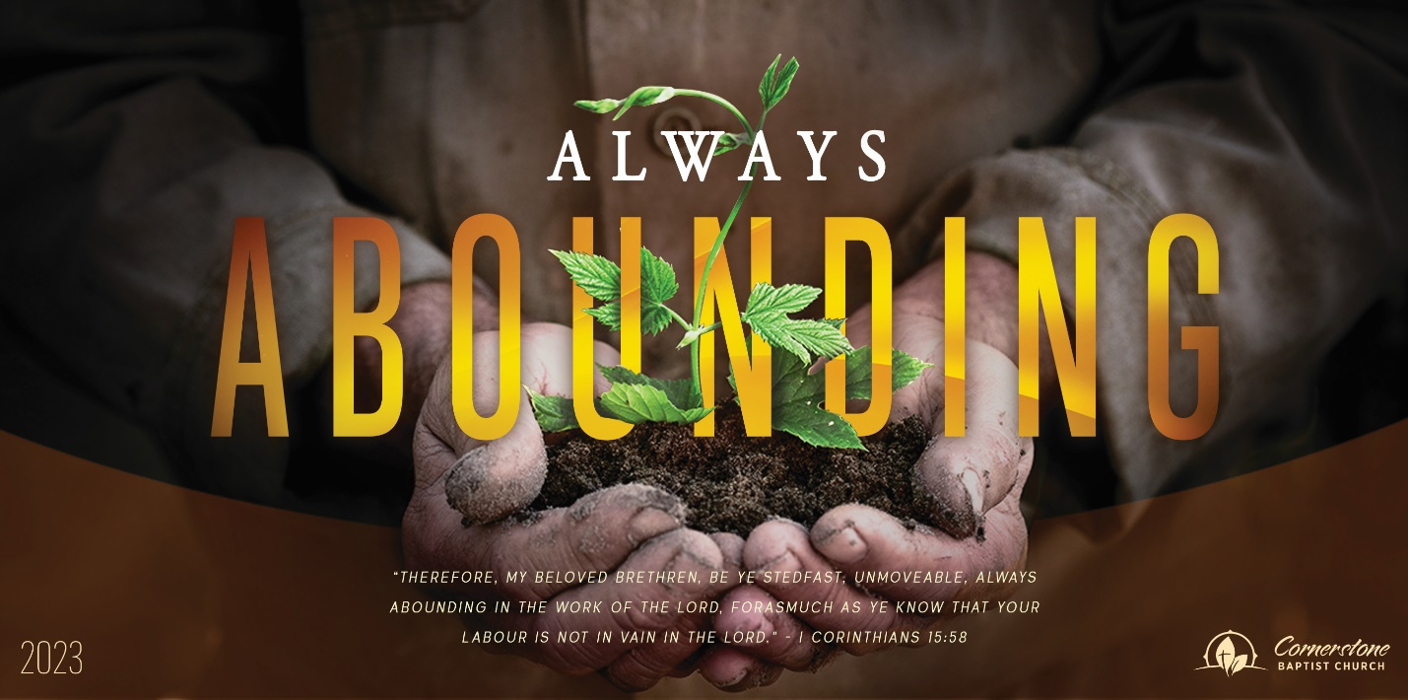
An Unprepared Heart
1 Kings 14:21-31; 2 Chronicles 12:1-16

Sunday Night, March 19, 2023
Cornerstone Baptist Church
315 Shoup Ave. West
Twin Falls Id 83301
208-733-5312 cbctwinfalls.com

An Unprepared Heart
1 Kings 14:21-31; 2 Chronicles 12:1-16
Introduction:
Jehu: 2Ch 19:3; Ezr 7:10; Pro 29:16; 2Ch 12:1; Pro 4:23; Psa 119:80; Hag 1:5-6; 1Co 16:13; 1Co 15:58; Psa 78:36-38; Psa 112:7-8; Psa 10:17-18;
1Ch 29:17-19
- A __________________ _______________________ to God.
  - Self-benefit.
  - Self-comfort.
  - Self-establishment
- A _____________ ____________ in ______ _________________.
  - King Nebuchadnezzar.
  - King Saul.
- An Awareness of ___________________ but ___________________ Until the ___________ is to Be ________.
  - An overwhelming enemy.
  - An acknowledgment of failure.
  - A protection from complete consequences. (mercy)
- An ___________ of _____________ to Keep Up ______________.
  - Loss of gold shields.
  - Replacement by bronze.

Conclusion:
-A prepared heart has __________________.
-A prepared heart has ______________________.
-A prepared heart has _______________________.
-A prepared heart has no _________________________.

An Unprepared Heart
1 Kings 14:21-31; 2 Chronicles 12:1-16

Sunday Night, March 19, 2023
Cornerstone Baptist Church
315 Shoup Ave. West
Twin Falls Id 83301
208-733-5312 cbctwinfalls.com

An Unprepared Heart
1 Kings 14:21-31; 2 Chronicles 12:1-16
Introduction:
Jehu: 2Ch 19:3; Ezr 7:10; Pro 29:16; 2Ch 12:1; Pro 4:23; Psa 119:80; Hag 1:5-6; 1Co 16:13; 1Co 15:58; Psa 78:36-38; Psa 112:7-8; Psa 10:17-18;
1Ch 29:17-19
- A __________________ _______________________ to God.
  - Self-benefit.
  - Self-comfort.
  - Self-establishment
- A _____________ ____________ in ______ _________________.
  - King Nebuchadnezzar.
  - King Saul.
- An Awareness of ___________________ but ___________________ Until the ___________ is to Be ________.
  - An overwhelming enemy.
  - An acknowledgment of failure.
  - A protection from complete consequences. (mercy)
- An ___________ of _____________ to Keep Up ______________.
  - Loss of gold shields.
  - Replacement by bronze.

Conclusion:
-A prepared heart has __________________.
-A prepared heart has ______________________.
-A prepared heart has _______________________.
-A prepared heart has no _________________________.

