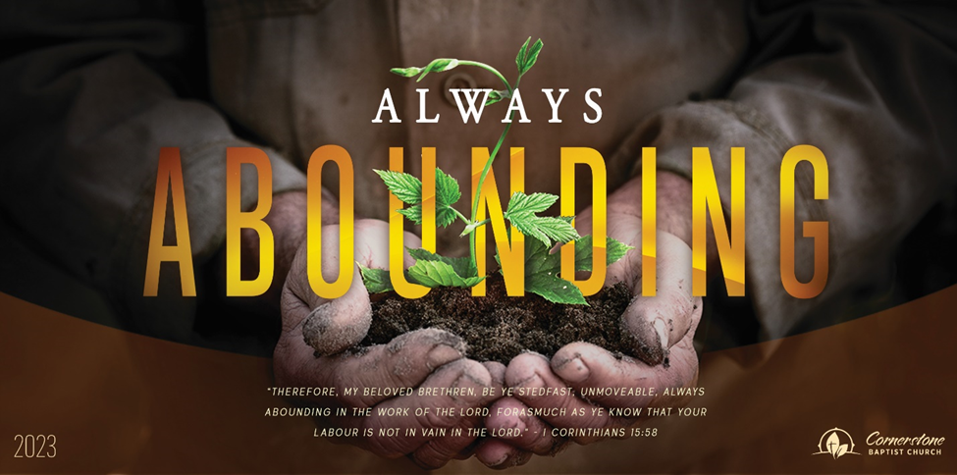

Wednesday February 1, 2023
What Do You Occupy?

315 Shoup Ave. West
Twin Falls Id 83301
208-733-5312 cbctwinfalls.com

What Do You Occupy?
Luke 19:11-27

Introduction:
A parable of purpose.
2Sa 7:16-17; 1Ch 17:14-15; Isa 11:1-2; Luk 1:32-33; Luk 17:20-21; Act 1:6-8
- The Kingdom’s _______________________.
  - He is gone for now.
  - He will return.
- The Kingdom’s ________________________.
1Co 3:11-15; 2Co 5:10
  - A valuable trust.
  - A trackable trust.
  - An accountable trust.
    - 2Co 5:11
- The Kingdom’s ____________________________.
  - A multiplied reward.
  - Reward is not related to salvation. Reward is beyond our salvation.
  - Saved as by fire.
    - 1Co 3:15
- The Kingdom’s ___________________________.
  - Hatred of the King.
  - Rejection of the King’s rule.
  - Judgment of their sin.
    - Loving the world. James 4:4
    - Rejecting the Gospel. 2 Thes. 1:8

Conclusion:

Wednesday February 1, 2023
What Do You Occupy?

315 Shoup Ave. West
Twin Falls Id 83301
208-733-5312 cbctwinfalls.com

What Do You Occupy?
Luke 19:11-27

Introduction:
A parable of purpose.
2Sa 7:16-17; 1Ch 17:14-15; Isa 11:1-2; Luk 1:32-33; Luk 17:20-21; Act 1:6-8
- The Kingdom’s _______________________.
  - He is gone for now.
  - He will return.
- The Kingdom’s ________________________.
1Co 3:11-15; 2Co 5:10
  - A valuable trust.
  - A trackable trust.
  - An accountable trust.
    - 2Co 5:11
- The Kingdom’s ____________________________.
  - A multiplied reward.
  - Reward is not related to salvation. Reward is beyond our salvation.
  - Saved as by fire.
    - 1Co 3:15
- The Kingdom’s ___________________________.
  - Hatred of the King.
  - Rejection of the King’s rule.
  - Judgment of their sin.
    - Loving the world. James 4:4
    - Rejecting the Gospel. 2 Thes. 1:8

Conclusion:

