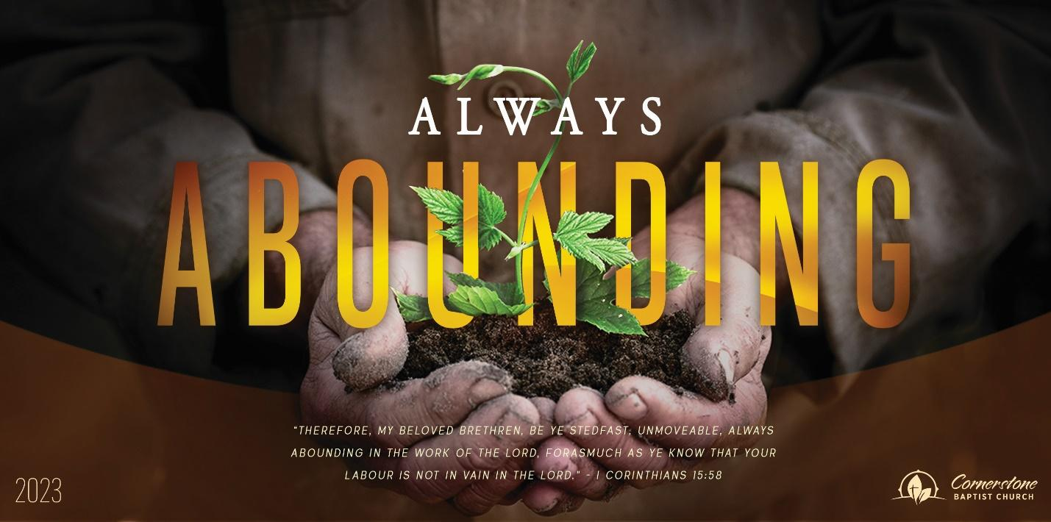

Decision Time

Genesis 13:4-18

Sunday Night, July 17, 2022

Cornerstone Baptist Church

315 Shoup Ave. West

Twin Falls Id 83301

208-733-5312 cbctwinfalls.com

Decision Time

Genesis 13

Introduction:

[Rev 2:3](verseid:66.2.3)-4

1. The ____________________ to an ____________________.
   * Humility leads back to beginning point.
   * Humility leads repentance.
2. The _____________________ of ___________________.
   * Getting to the cross changes everything.
   * Getting to the cross renews hope and gives help.
3. The _____________________ _______________________.
   * Conflict of wealth.
   * Conflict of heart.
4. The _____________________ of __________________________.
   * Lot is given the choice in spite of his position.
   * Lot is given the choice in spite of Abram’s promise.
   * Lot views the ease of the plain of Jordan and chooses for himself.
5. The ___________________________ ________________________.
   * The promise of the land forever.
   * The promise of the land to his descendants.
   * The promise of many descendants.

Conclusion:

_____________________ through the _________________.

Abram built an ____________________.