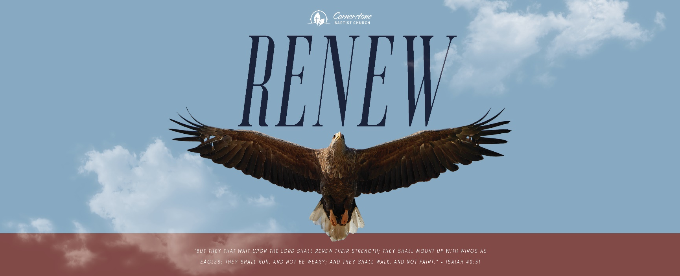

The Stubborn Man
1 Kings 12:1-15

Sunday Night, January 15, 2022
Cornerstone Baptist Church
315 Shoup Ave. West
Twin Falls Id 83301
208-733-5312 cbctwinfalls.com

The Stubborn Man
1 Kings 12:1-15

Introduction:
1Sa 8:10-19; Ecc 2:18-19; 2Ch 13:7

- Seeking ____________________ Not ___________________.
  - Consulting the elders.
  - Consulting the young men.

- _____________________ Not ____________________.
  - Know it all attitude.
  - Rejection of help.
- ____________________ Not _____________________.
  - Spirit of defiance.
  - Spirit of denial.
- ____________________ Not _____________________.
  - Loss of potential.
  - Loss of power.
  - Loss of position.

Conclusion:

He that is down needs fear no fall,
He that is low, no pride;
He that is humble ever shall
Have God to be his guide.—John Bunyan

Source: Pilgrim’s Progress, John Bunyan

The Stubborn Man
1 Kings 12:1-15

Sunday Night, January 15, 2022
Cornerstone Baptist Church
315 Shoup Ave. West
Twin Falls Id 83301
208-733-5312 cbctwinfalls.com

The Stubborn Man
1 Kings 12:1-15

Introduction:
1Sa 8:10-19; Ecc 2:18-19; 2Ch 13:7

- Seeking ____________________ Not ___________________.
  - Consulting the elders.
  - Consulting the young men.

- _____________________ Not ____________________.
  - Know it all attitude.
  - Rejection of help.
- ____________________ Not _____________________.
  - Spirit of defiance.
  - Spirit of denial.
- ____________________ Not _____________________.
  - Loss of potential.
  - Loss of power.
  - Loss of position.

Conclusion:

He that is down needs fear no fall,
He that is low, no pride;
He that is humble ever shall
Have God to be his guide.—John Bunyan

Source: Pilgrim’s Progress, John Bunyan

