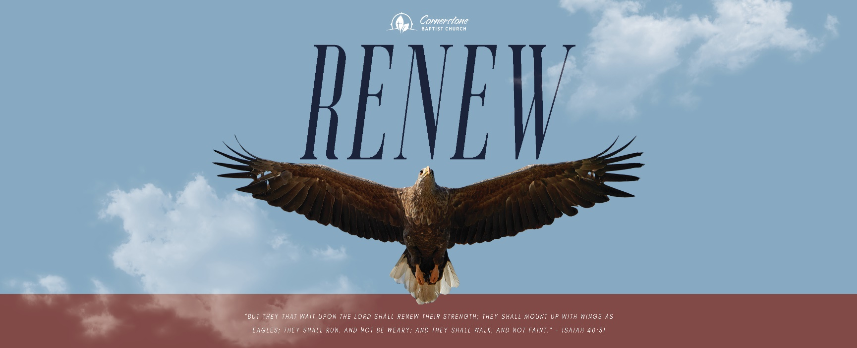

Sunday January 15, 2023

Seek the Lord

Cornerstone Baptist Church
315 Shoup Ave. West
Twin Falls Id 83301
208-733-5312 cbctwinfalls.com

Strength Renewed
Isa 40:31 But they that wait upon the LORD shall renew their strength; they shall mount up with wings as eagles; they shall run, and not be weary; and they shall walk, and not faint.

Introduction:
Jas 1:2-4; Rom 10:17; Joh 1:11-12; Php 4:19

- God’s ______________________. 1Pe 5:6-9
  - Body, soul, and spirit. 1Th 5:23
  - Relationally.

- God’s ______________________. Eph. 6:10-11; Heb 4:3
  - Strength for today.
  - Strength for specific areas of life.
  - Strength beyond what we know.
Mat 11:28-29

- God’s _________________________.
Eph 2:10; Heb 13:21
  - An active life.
  - A productive life.
  - A demonstrative life.

Conclusion:

Sunday January 15, 2023

Seek the Lord

Cornerstone Baptist Church
315 Shoup Ave. West
Twin Falls Id 83301
208-733-5312 cbctwinfalls.com

Strength Renewed
Isa 40:31 But they that wait upon the LORD shall renew their strength; they shall mount up with wings as eagles; they shall run, and not be weary; and they shall walk, and not faint.

Introduction:
Jas 1:2-4; Rom 10:17; Joh 1:11-12; Php 4:19

- God’s ______________________. 1Pe 5:6-9
  - Body, soul, and spirit. 1Th 5:23
  - Relationally.

- God’s ______________________. Eph. 6:10-11; Heb 4:3
  - Strength for today.
  - Strength for specific areas of life.
  - Strength beyond what we know.
Mat 11:28-29

- God’s _________________________.
Eph 2:10; Heb 13:21
  - An active life.
  - A productive life.
  - A demonstrative life.

Conclusion:

